E-RESERVES
Scanning

Some things to remember pre-scan:
- If possible, clean up copies before scanning – remove black spaces, straighten angles, etc.
- With periodical articles: Check the electronic databases (EBSCO, Pro-Quest, CINAHL, etc.) to see if they contain a full-text version of the article. If they do, try to match .pdf format and right-click the link to the article to save it to your hard drive (if the article is in MS Word – “.docx” or “.doc”, you will need to convert that to a .pdf using Adobe Professional.)
- Note that if you put the article into the scanner print-side-up & top of the page in line with the feeder entrance, the article will come up right-side-up when scanned, necessitating less manipulation.
- Also, pages can scan “skewed” (we’re not sure why they do this, it’s just guaranteed that you’ll have at least 2 of them in a 65-page article.) Unless this makes the text unreadable or crops off parts of the article, don’t worry about re-scanning. Just crop as good as you can and be done with it.
- Finally, the scanner does get tired and/ or irritable. If you have a paper jam, you’re going to have to close out of the open windows and re-start from scratch. If you’re scanning anything over about 10 pages in length, the best way to handle it is to scan 10 pages at a time in batches. This gives you a more “workable” number of pages, as well as reducing the chance of skewed pages, missed pages, or otherwise needs-to-be-re-scanned pages. Murphy’s Law is operative here – the bigger the article, the greater chance that something will happen to cause you to have to run it through the ADF (Auto-Document Feeder) four times.

- Turn the scanner on. (this is the one with the standard vertical-line-within-an-open-circle graphic on it. Most PC CPU’s have this symbol on their power buttons if the symbol doesn’t sound familiar.)
- Make sure that the scanner is set to scan in black & white (all e-reserve articles must be scanned in black & white.) You will see a button that has a blue dot and a red dot next to it, with another button underneath with a white dot and a black dot. Toggle the buttons until the light next to the black & white dots is lit.
- Double-click the “HP Director” button:

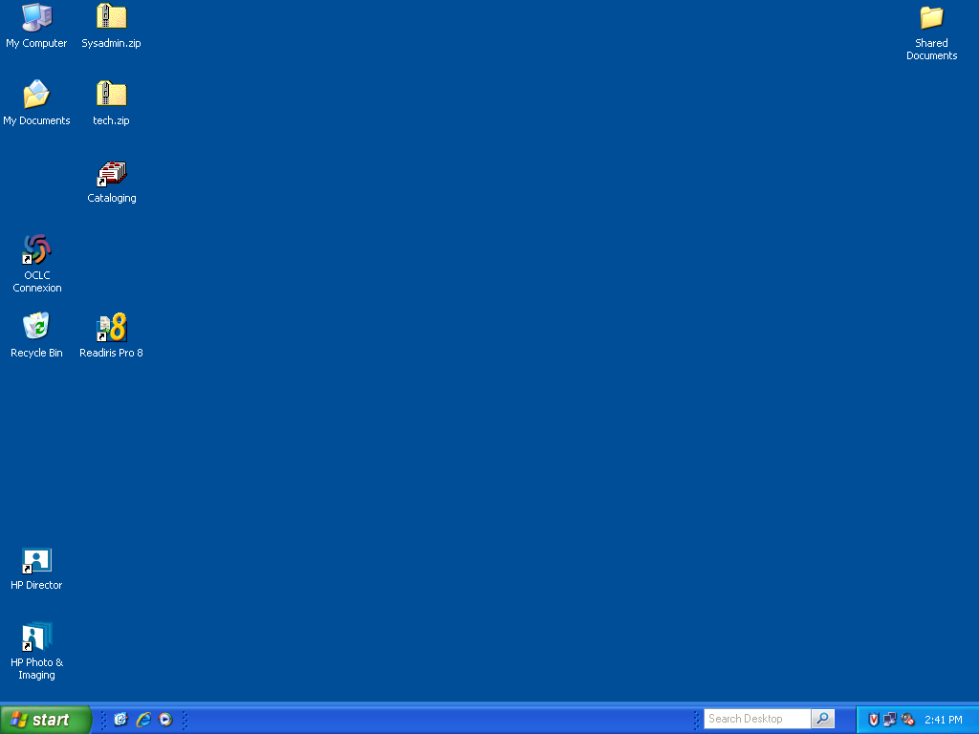
- Load your document either onto the scanner-glass (face down) or into the ADF (face up; if you place it with the top of the page facing the feeder, the image will scan right-side up and require less manipulation.)

- Double-click on “Scan Document”: 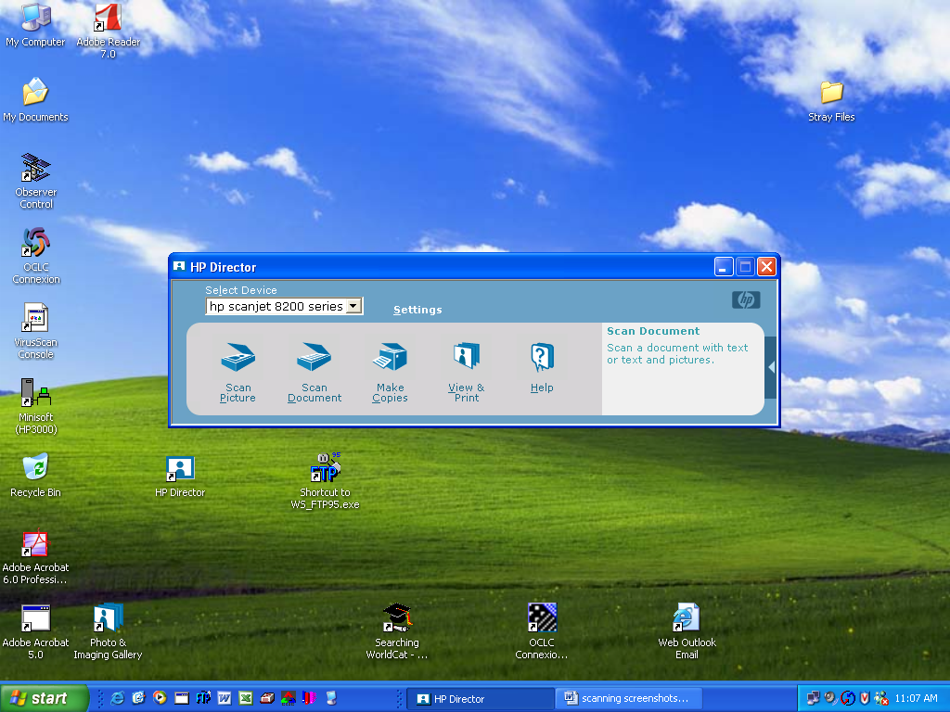

- The “HP Scanning” window comes up. Occasionally this will come up behind the “HP Director” window, causing the icon in your taskbar to flash orange. Either click the icon or the window itself to make the window active.
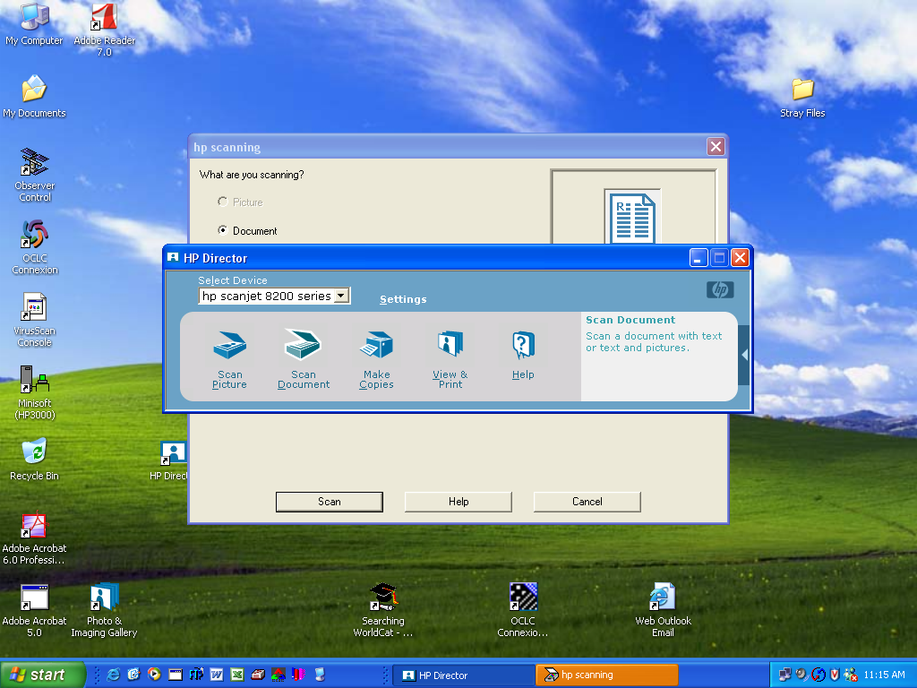

- When the window is active, verify the following settings:
- “Scan for editable text (OCR)?” – No
- “Original contains graphics?” – No
- “Scan to” – Save to file

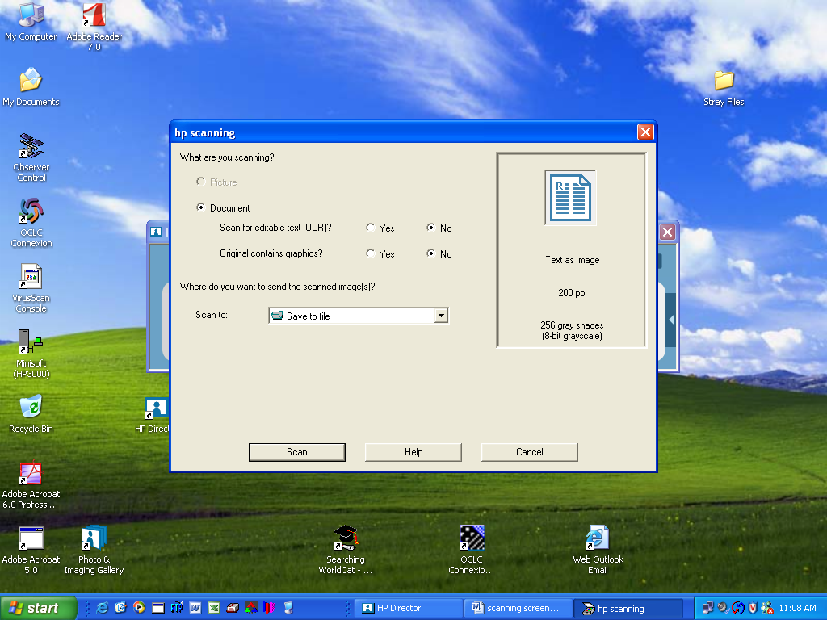
- Click “Scan”
- A transitional screen briefly comes up:

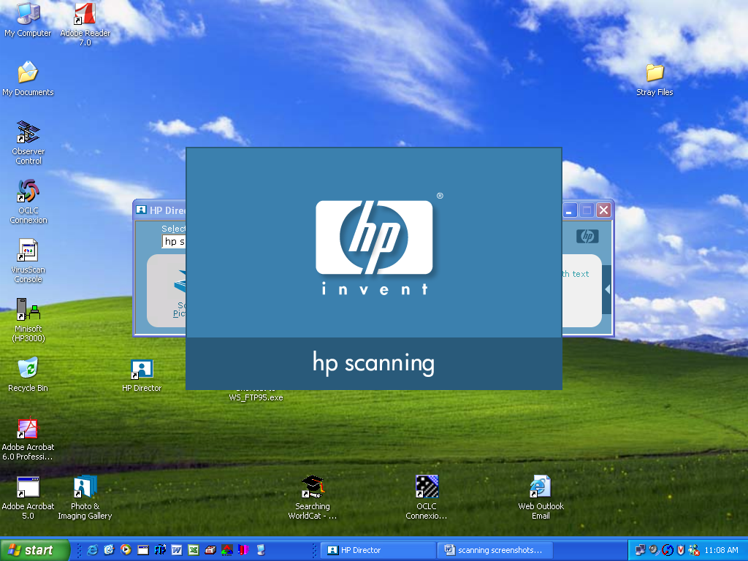

- Most of the time you will see the “warming up the lamp” message in the “HP Scanning” window first. The amount of time that it stays up varies, depending on if you’re just starting to scan or have been scanning for a while. Be warned: this screen doesn’t always show up, and the scanner starts to scan immediately after it displays this, so make sure the documents you’re scanning are in place!
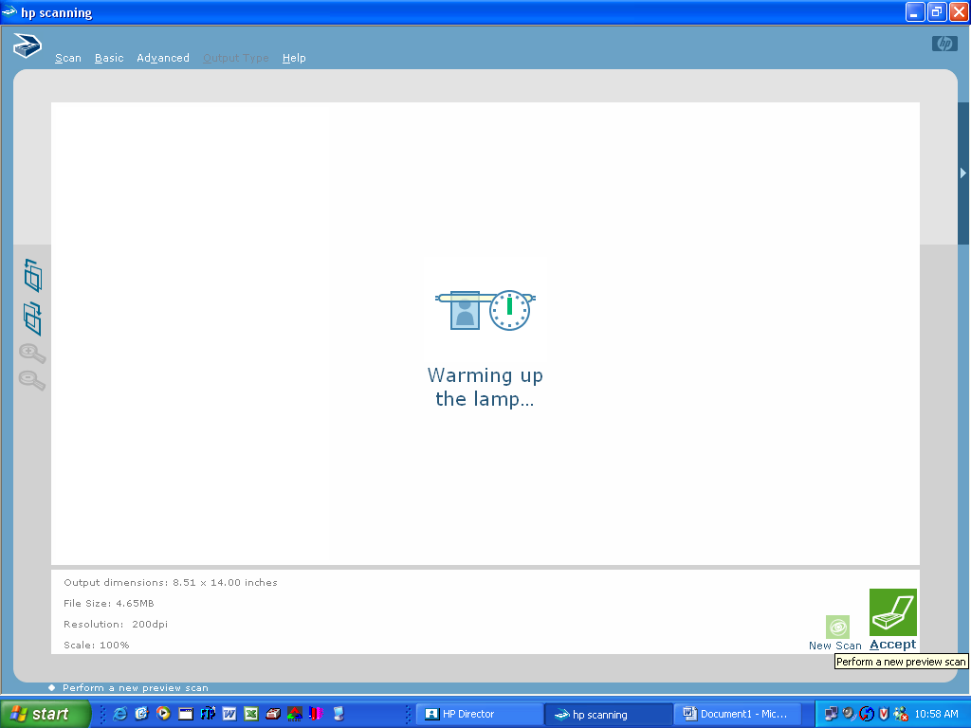

- When the scanner has finished its preliminary scan, the window will show a preview of what your scan is going to look like:
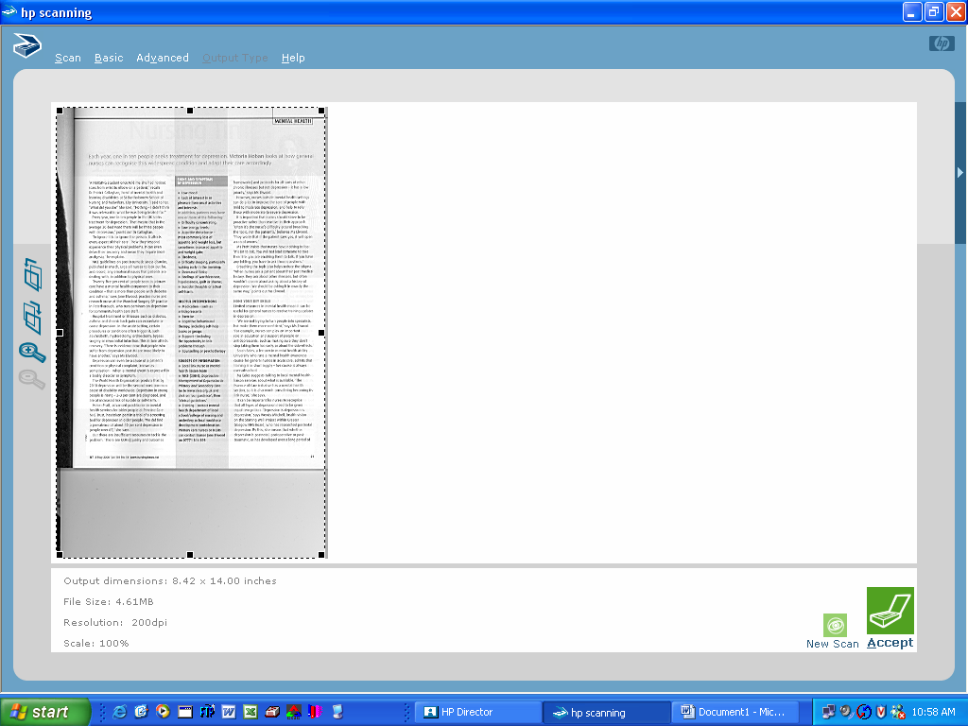

- The top icon to the left of the preview rotates the image counter-clockwise.
- The middle icon rotates clockwise.
- The first magnifying glass icon zooms in.
- The second magnifying glass icon zooms out (and the icon is grayed out in this case because the scanner is showing a full-sized preview – the gray space under the page is actually a scanned part of the scanner cover.)
- The dotted lines are moveable and used to crop off unwanted parts of the image (like the gray or solid black areas – the “cleaner” the image is, the easier it can be read.) At this point, you are indicating where you want to scanner to crop when it creates the actual scanned image.

Cropped Image (pre-scan):
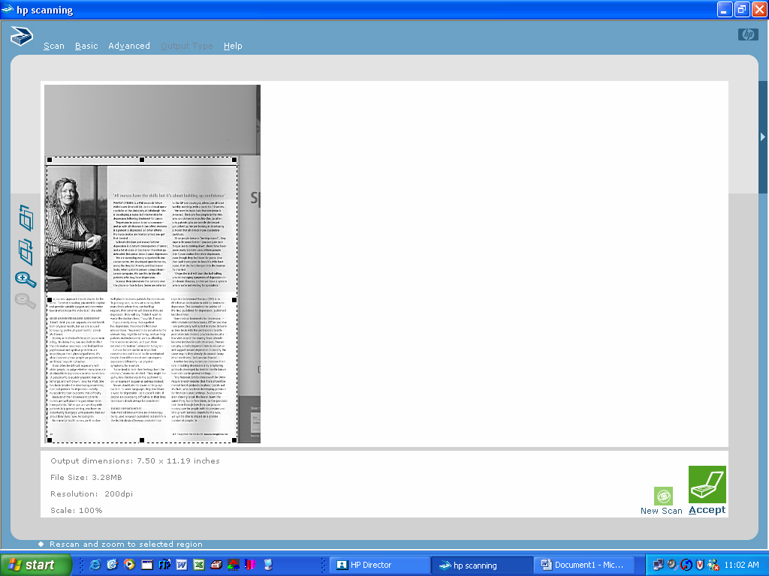

- When you’re done modifying click on the “accept” icon:
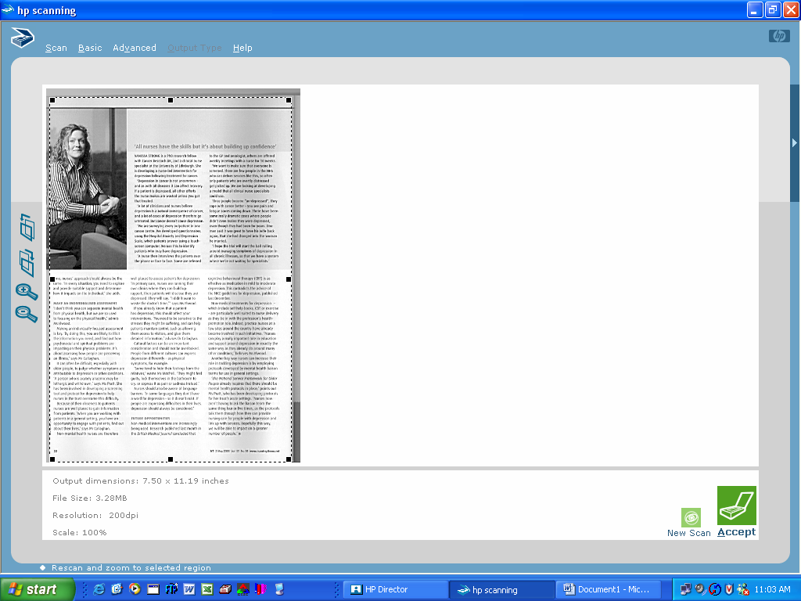

- If you are scanning more than one page into the file (hopefully using the document feeder…) you will find that the program keeps track of how many pages you’ve scanned – it will always send you back to the first page you scanned to begin modifying the images.
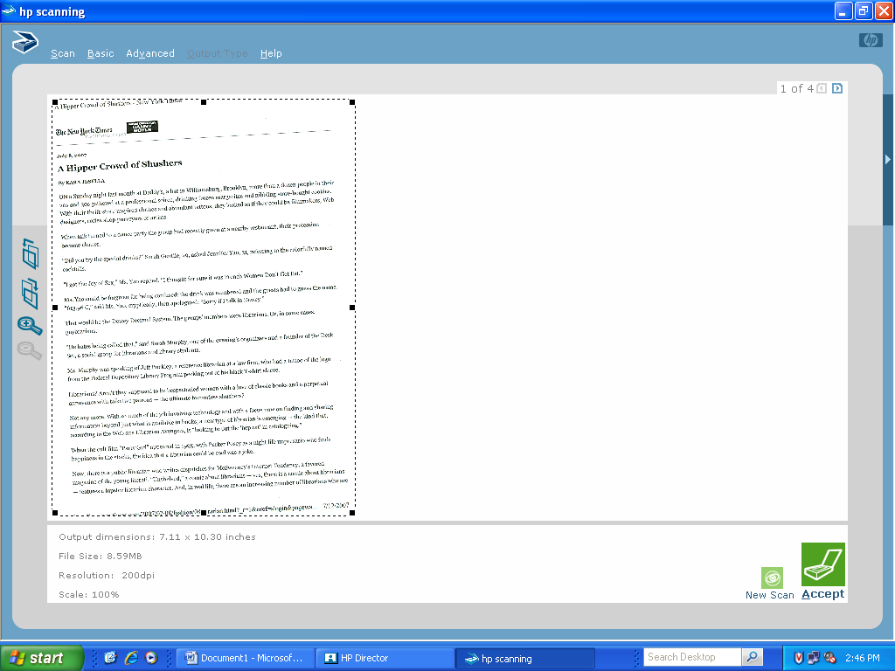

- The scanner will scan each page individually to account for the modifications you’ve made. Then a screen will pop up asking if you want to scan more or if you’re done.
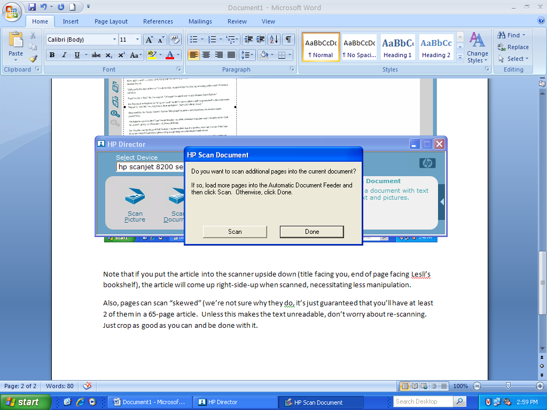

- Obviously, with a huge article you’re going to want to do it in pieces, so you would click “Scan” after each successive batch. When you’re done, click “Done”.
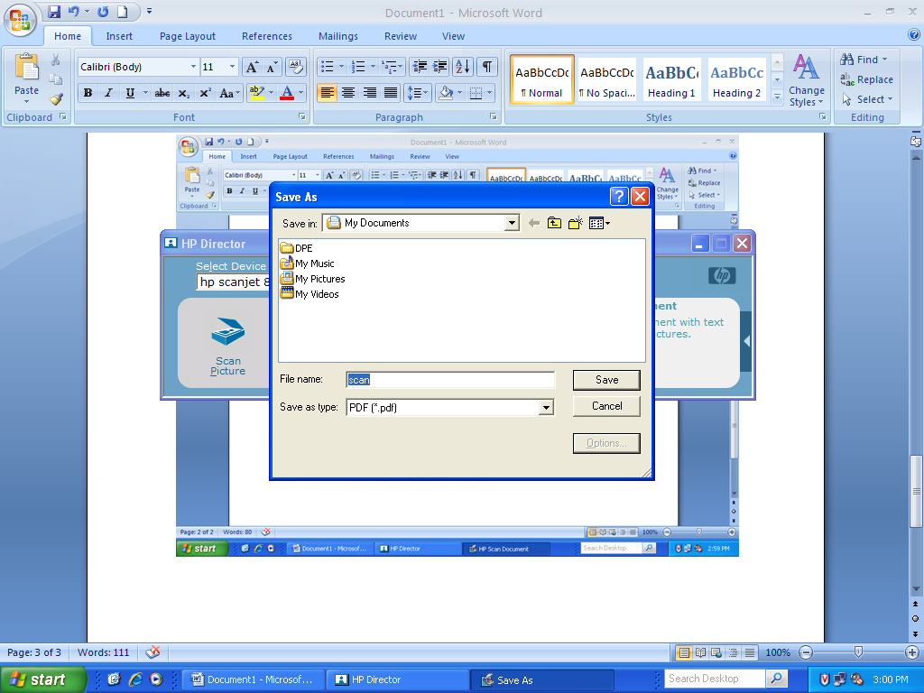

- This is very important. Make sure that the “Save as type:” drop-down window says PDF (*.pdf) – Adobe cannot convert some files into .pdf format, so if you save as .rtf, for example, you have just spent 30 minutes arguing with the scanner over a 65-page document for nothing.
- You also want to make sure that you’re saving to the right directory (Double click: X → InstSrv → HL → Circulation → ereserves → the folder of the faculty member who is putting the items on e-reserve. (“chartse” in this case. As a rule, the folders are supposed to be named with the instructor’s first initial and last name.)

- Another very important step to remember. When you name the document, make sure the name is all in lowercase with no spaces. E-reserve documents are named after the last name of the author (plus a number if a professor is fond of using more than one article by a particular author.) However, if the file or the URL is capitalized, the link in the library catalog will automatically lead to an error screen, and you’re looking at re-doing a significant amount of work over again.
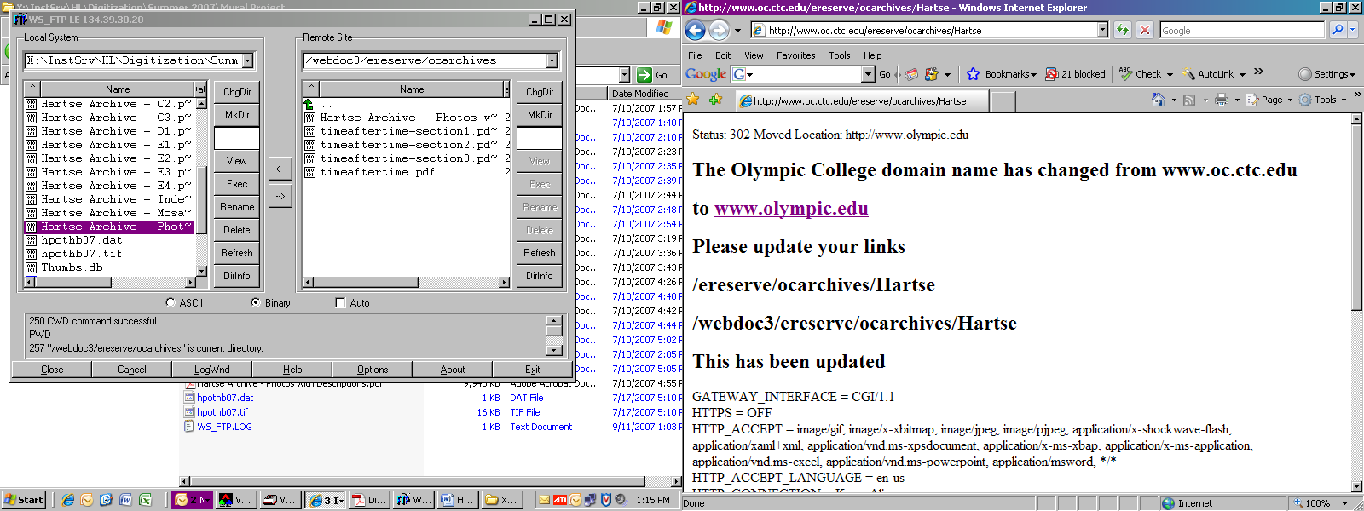

- (Note that this actually has nothing to do with the domain name change. It’s solely the capital letter/ space it can’t deal with.)

- Again, you will see the computer process individual pages:
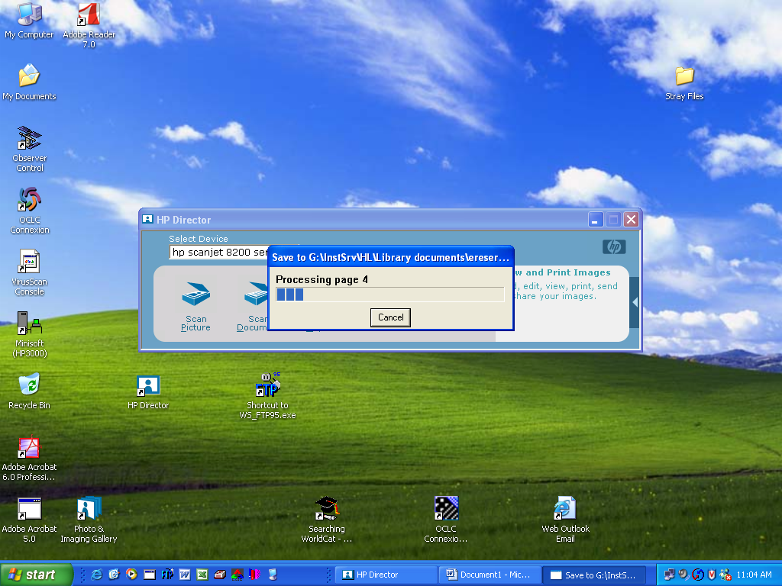

- After that it’s back to the HP Director screen again. Either continue scanning or close out the director.
Securing the Document in Adobe Professional

- In Adobe Professional click “File → Open” or just click the folder icon on the third menu down. This will probably bring you to the “My Documents” folder. You’re going to want to be in the X: Drive in the section of the Library’s folder that deals with the e-reserves for whichever faculty member you’re dealing with (listed in # 14 in the previous section.) Open the .pdf file you’re working with.

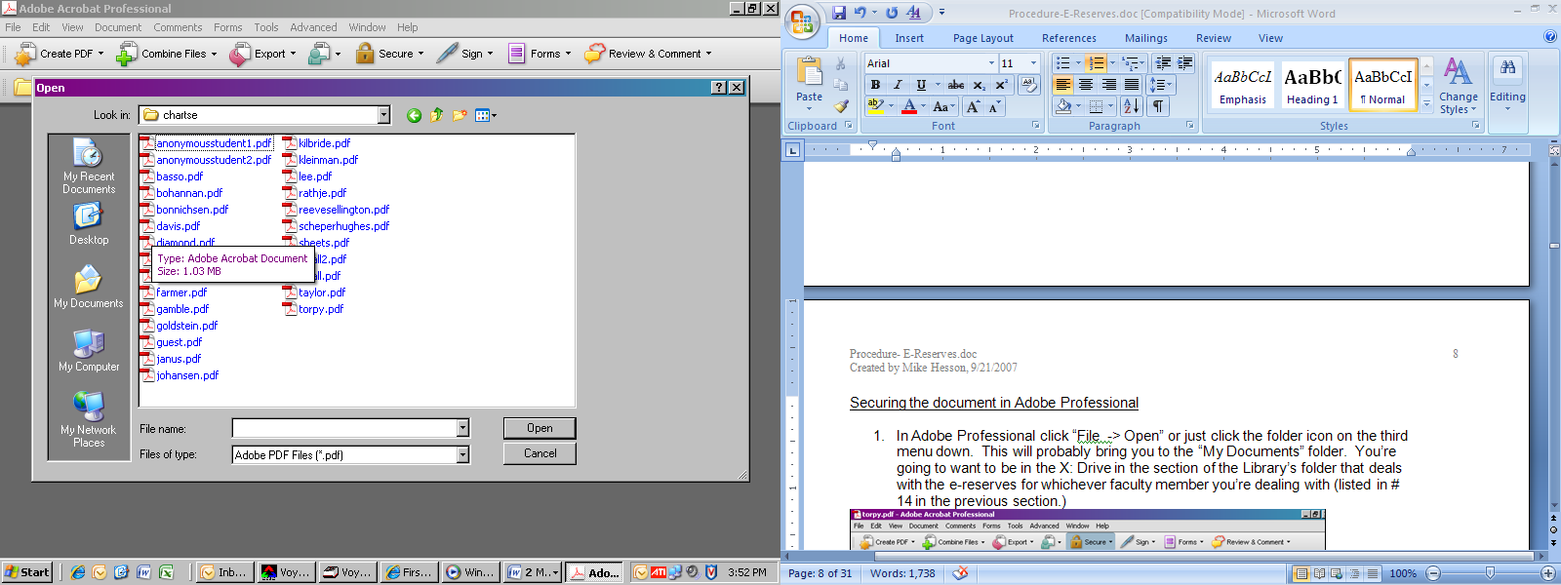

- Size the document to 100% and go through it page by page to make sure that the scanner didn’t miss any pages, any skewed pages are readable, etc.
- In the “Secure” menu drop-down choose “Password Encrypt.”

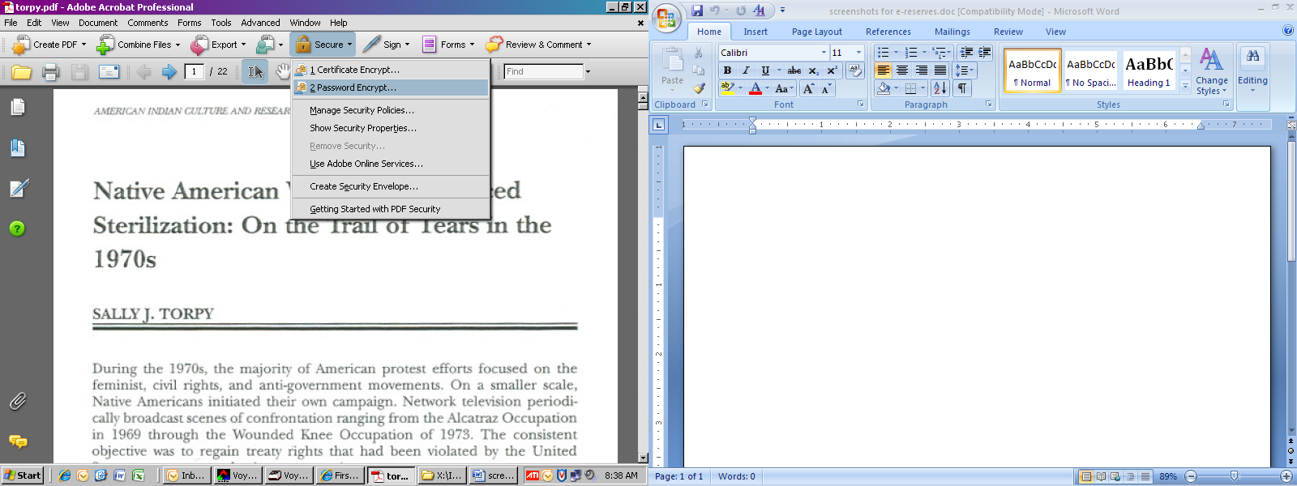

- This will open the “Password Security – Settings” menu. You want to check the box that is titled “Require a password to open the document.” This is the only box that you want to check (as we don’t want to restrict our students’ right to print these things.)

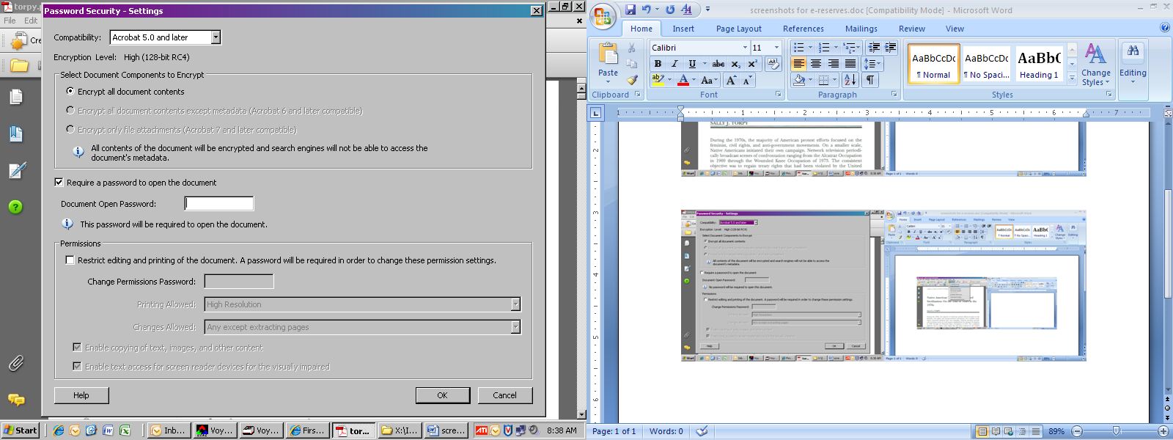

- The password will always be the instructor’s last name, all in lowercase. Enter it in the field (please make sure your spelling is correct) and click “OK”.

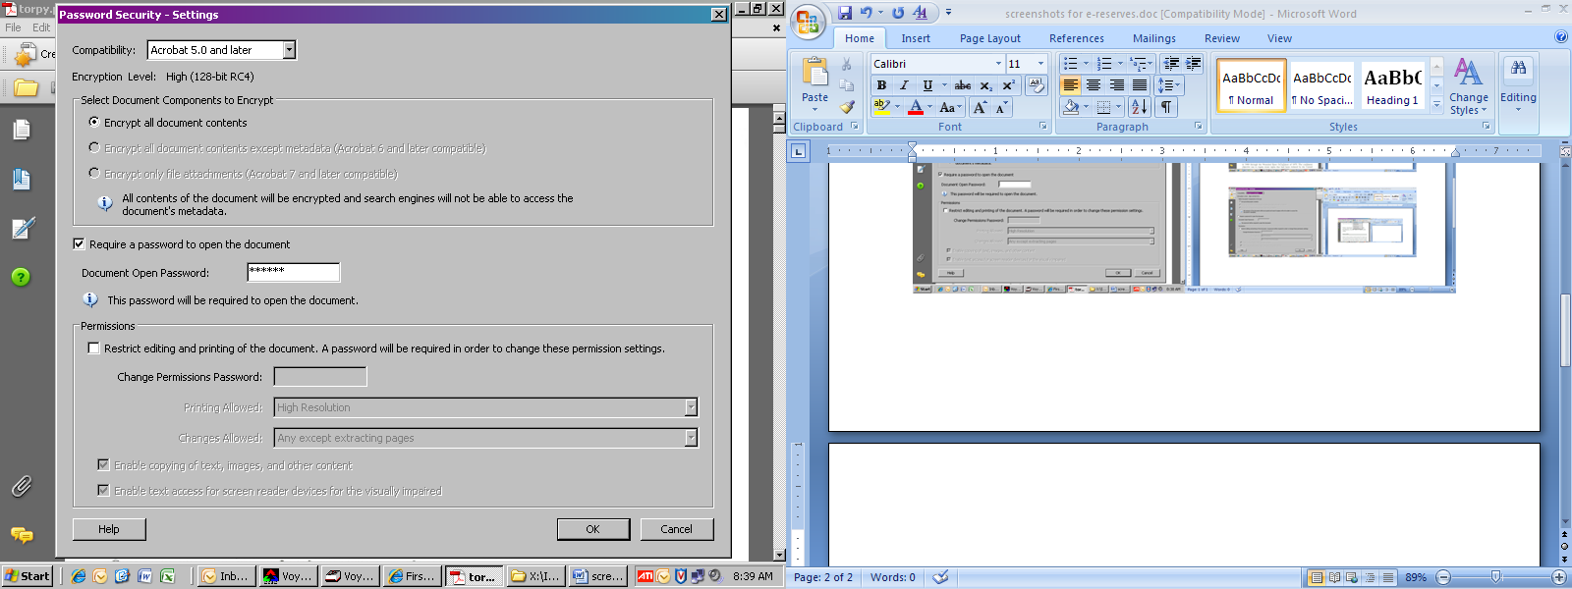

- A window will pop up asking you to confirm the password. Enter the instructor’s name in lowercase letters again and click “OK”.
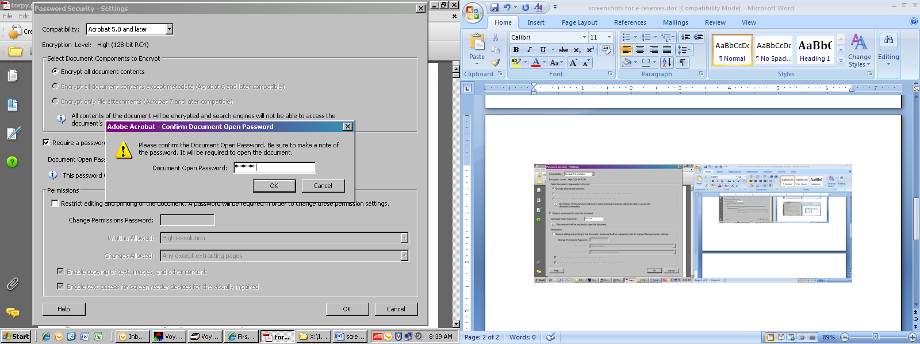

- Try to remember to save your changes…
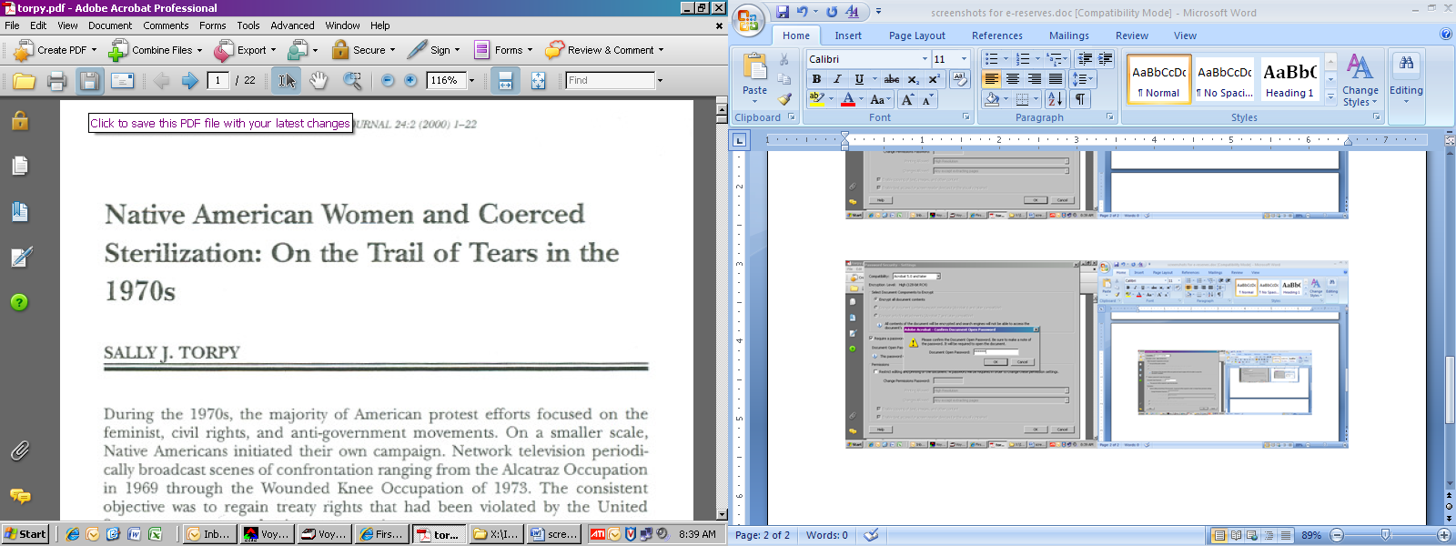

- …but if you’re like me and have a hard time not just “x-ing out” of the document, Adobe will prompt you to save. Click “Yes”.
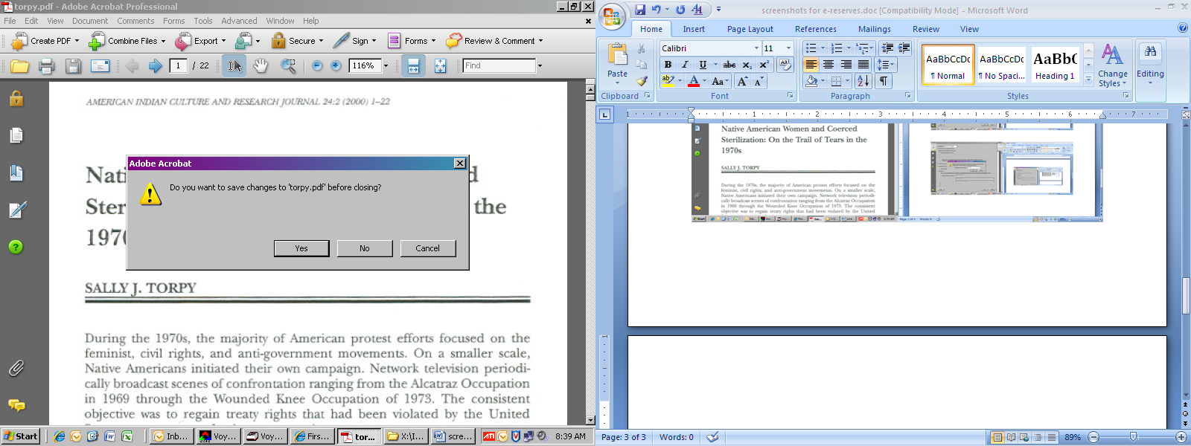

- In the event that you’ve just messed up a faculty member’s name twice, you will need to remove the password from the document so that you can re-enter it. Click Advanced → Security → Remove Security. The usual “are you sure?” screen will pop up. Click “OK”.

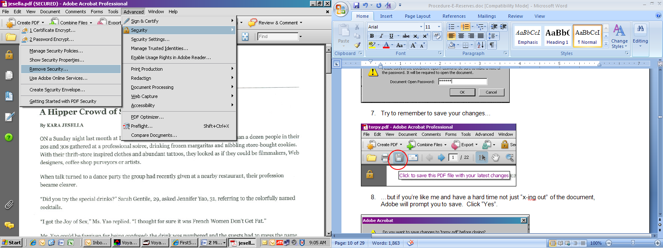

- Now you’re going to need to work up a listing of the articles you’re adding into a reserve list. This consists of a citation (usually in APA, although it’s discipline-specific, so use MFA when you can) and a URL where the file will be found. Both the cite and the URL are going to be visible in the online catalog, so double-check that you’re correct in spelling, usage, etc.
- If the list is new, save the list in: X:\InstSrv\HL\Circulation\ereserves\E-Reserves using the instructor’s full name as the document name (so, in this instance: “Hartse, Caroline.docx”, or .doc if you’re comfortable keeping things in word 2003 format)
- If the instructor already has an e-reserves list for that course, you’re going to want to add the new citations to the one that’s already in operation. These are listed the “E-Reserves” folder (path below):
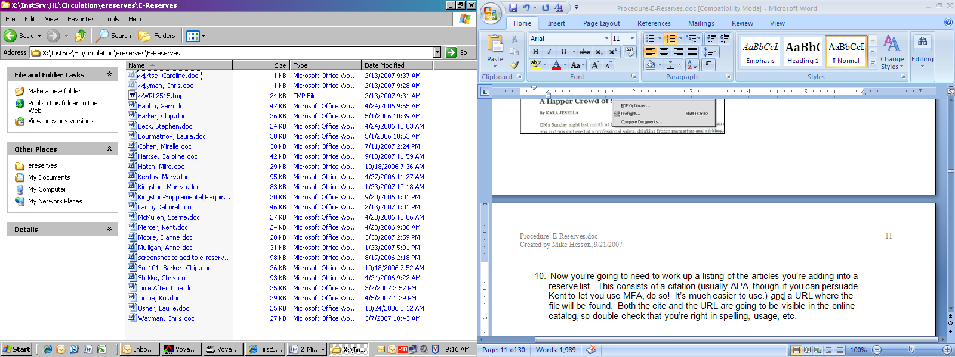

- The current list of e-reserves (below) is never 100% current. e-reserves are supposed to be “cleaned up” on an annual basis. However, we have had instructors call and ask that a list they previously used be made active again. Even if someone has left OC, this doesn’t mean that they won’t continue to teach online (Robin Newcomer did so for quite a while). So the safest course of action when an instructor no longer needs an e-reserve list up and running is to unlink it from the course in the Circulation module and leave it at that. If, after 2 years, an instructor has left and hasn’t taught, then remove them from the system.
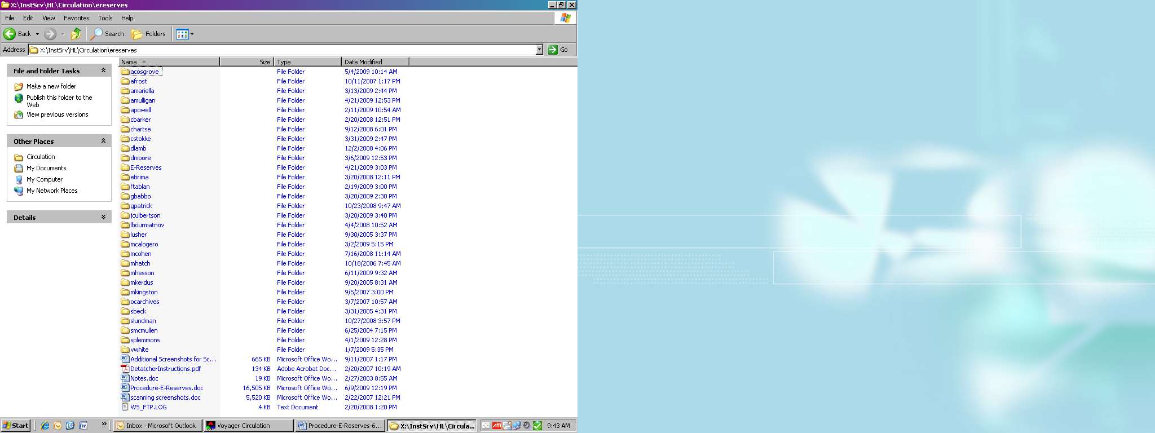

- Some things to be aware of with creating an electronic reserve list :
- 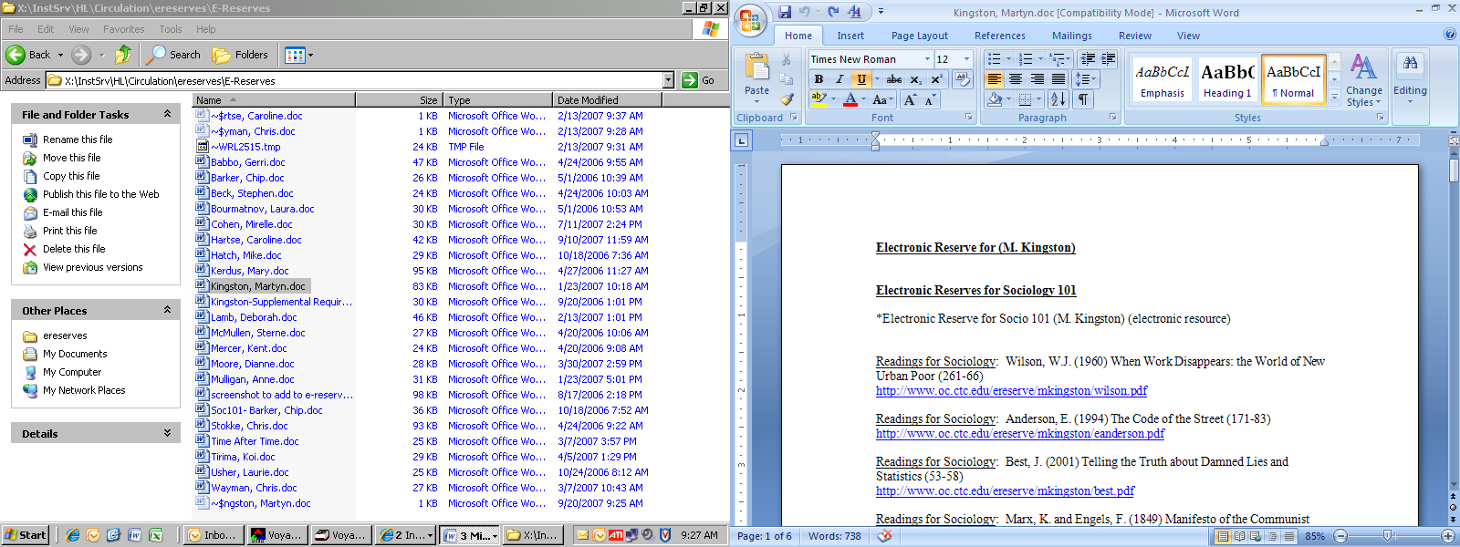You’re going to want to remember that this document is for all the e-reserves a particular professor has, so it should be titled as such and divided into sections by course number. Also: when you create the list-name for the individual course, make sure that you start it with an asterisk (*) – this ensures that it will be the first list to come up if a student is only searching via. instructor name.
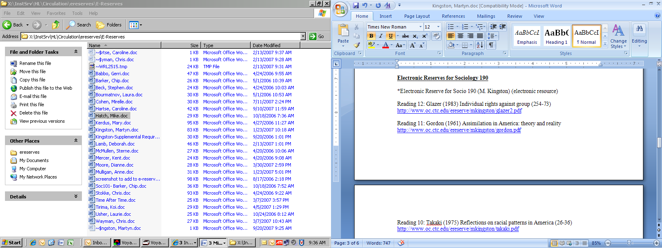
- Unfortunately, Voyager has a bug that forces you to enter your list in the opposite order of how you want it to appear. Our default is alphabetical, so alphabetize by author name and build the list Z-A. Many instructors have articles that they want the students to read in a certain order. It helps to title them as such, and then the list would start with the last reading:

- I’ve mentioned earlier that filenames need to be all in lower-case letters with no spaces. The same rule applies for the URL’s. I tend to create lists by copying one URL and then pasting it multiple times and modifying the line so that it reflects the author of the cite I’m using it for. If you’re one of those people who spots errors better on paper, then highlight the list you just created, print it, and proofread that way.
Uploading the files to the server via. WS-FTP

- Login.
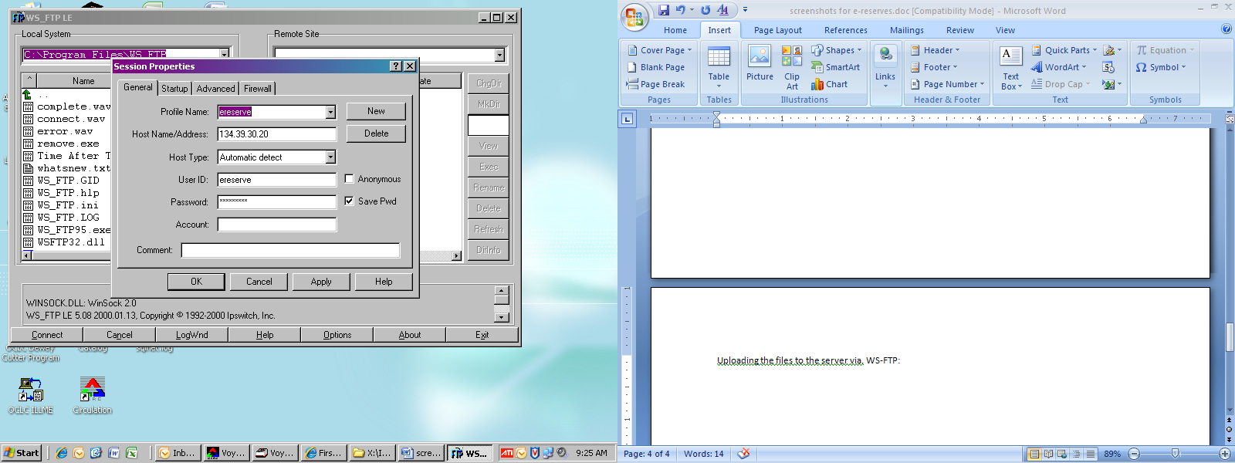

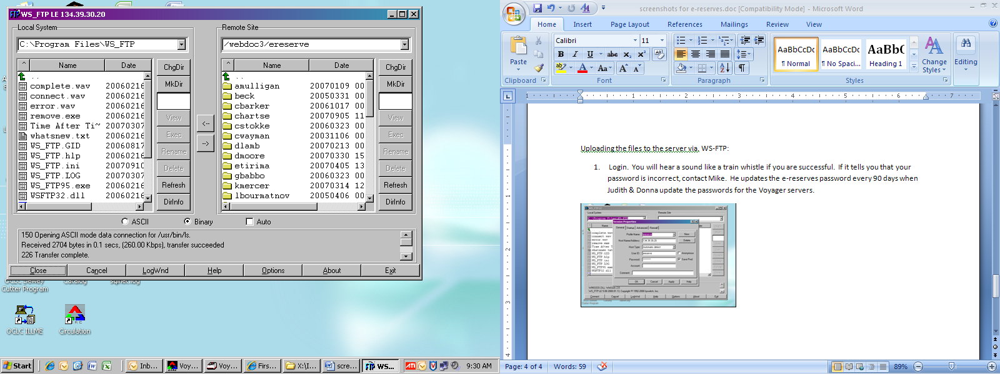

- Use the pull-down bar on the left window to find the X drive. This procedure is similar to getting to a folder on the common drive in windows. Double click: X → InstSrv → HL → Circulation → ereserves → chartse (in this case.)
- Also, make sure that you’re in the correct folder on the right-hand side. The window won’t go up past “/webdoc3/ereserve”, but you need to make sure you’re transferring files into the correct instructor folder. In the event that you’re dealing with brand-new faculty, you’re going to have to create a folder to parallel the one you created on the X: drive.
- First, Make sure that your folders parallel each other. Ideally you want to find the spot where the folder you need to create is listed in the X: drive, but not in the /webdoc3/ereserve folder listing. In this case, the folder in question is mine (mhesson).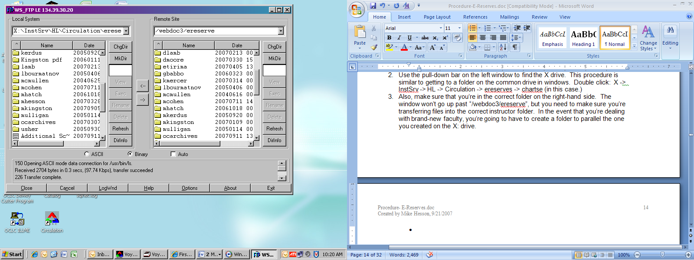

- Then you’re going to want to click “MkDir” over in the far right column of buttons on your WS-FTP window.

- This will bring up a pop-up window that wants to know what you’re naming the new folder. Enter the info and click “OK”.
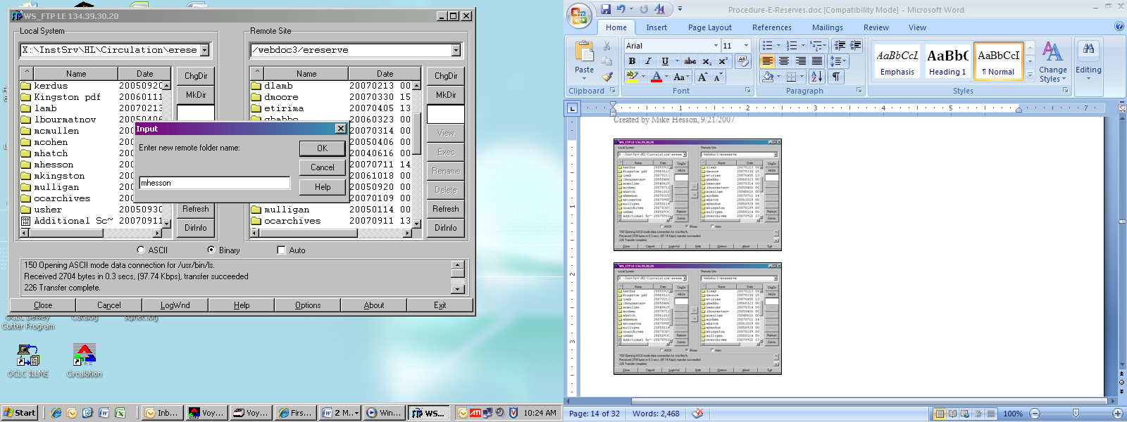

Your new folder should now be in both sides of the program window.
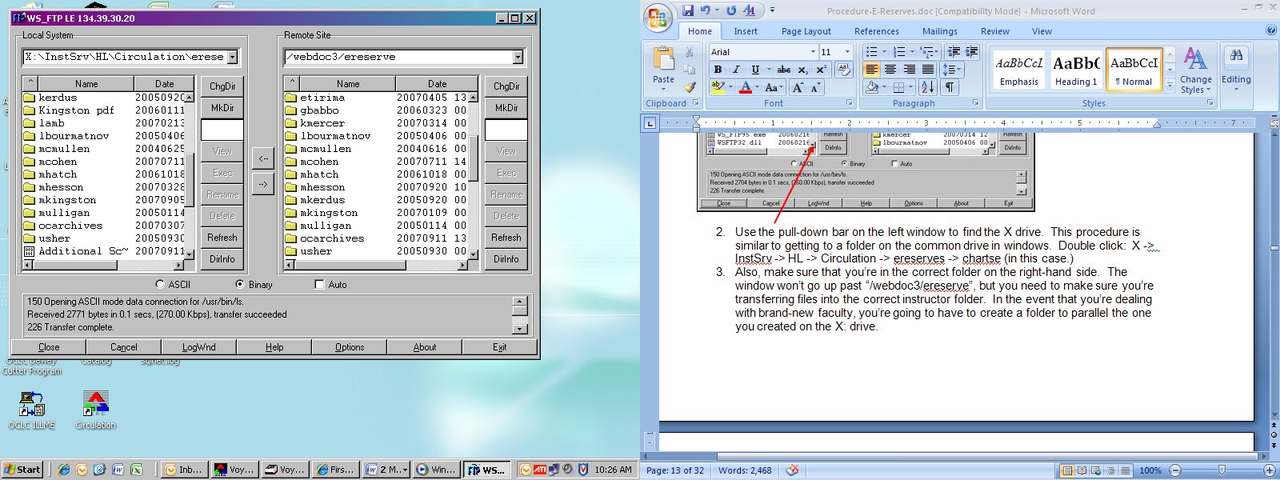

- Assuming you were already in the instructor folder in the left-hand side, double-clicking on the correct instructor folder on the right-hand screen will get you two almost-identical lists.
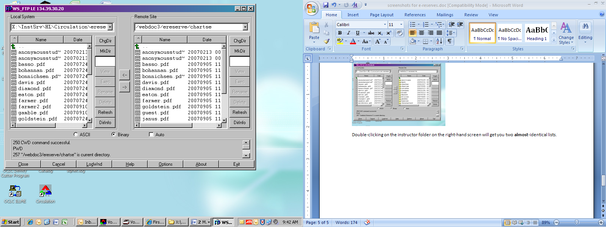
- The new filenames on the left-hand window (i.e.: the ones that don’t show up in the right-hand window) are the files that you need to upload. I always double-check with the course-reserve citations list to ensure that I’m uploading all of them.
  - Click on the filenames to highlight them (pressing the “Ctrl” key while doing this allows you to highlight multiple individual files.)

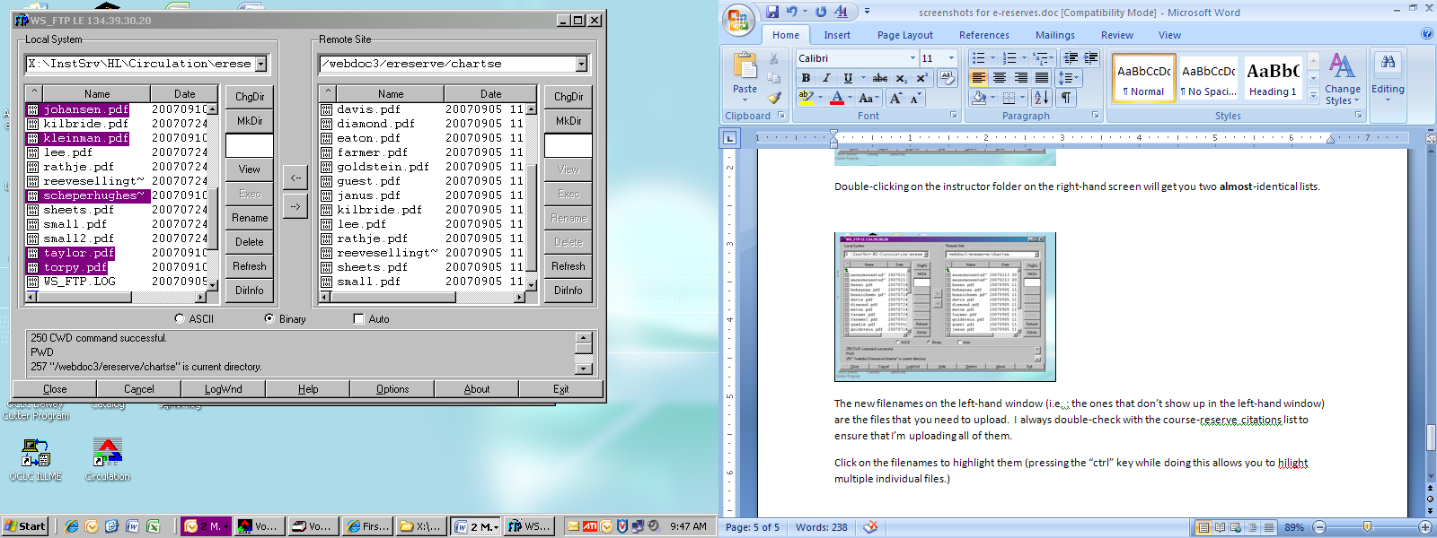

- Then click the arrow pointing to the right. This will start the upload process.
You will see individual screens showing the progress for each document you upload (they come up one after another):

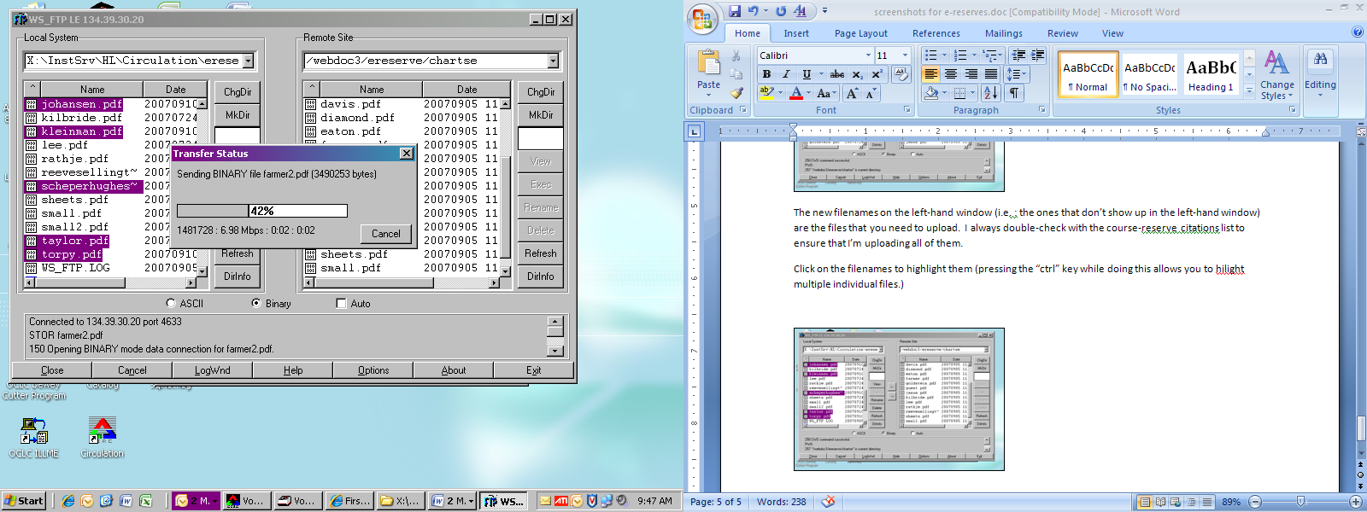

- When the process is finished, the bottom of your screen will have some techno-babble that will include two phrases to look for: “transfer succeeded” and “Transfer complete.” Click on the “Exit” button to exit.
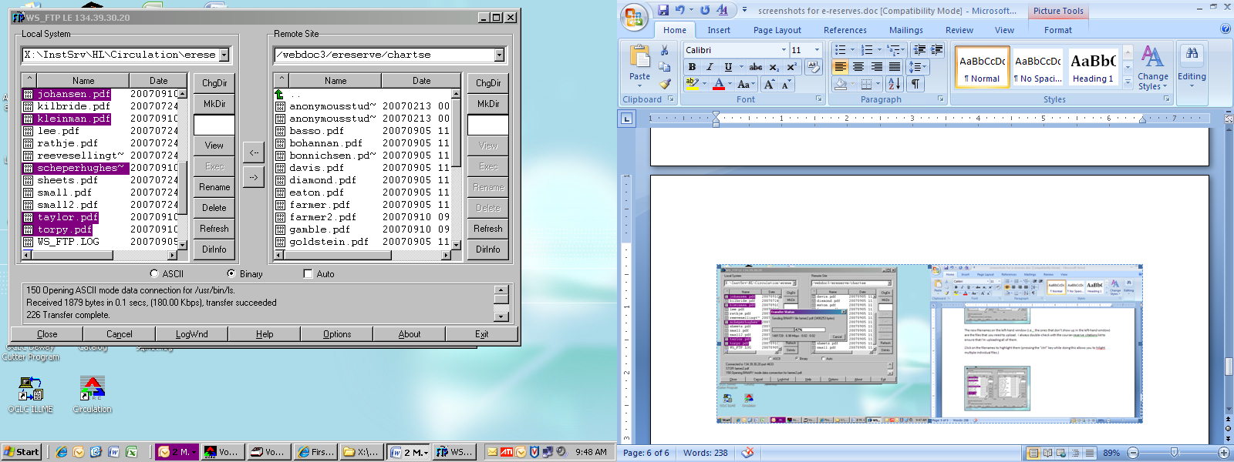

Linking the e-reserves in Voyager Circulation Module

- Pull up the list of the cites & URL’s that you created earlier.

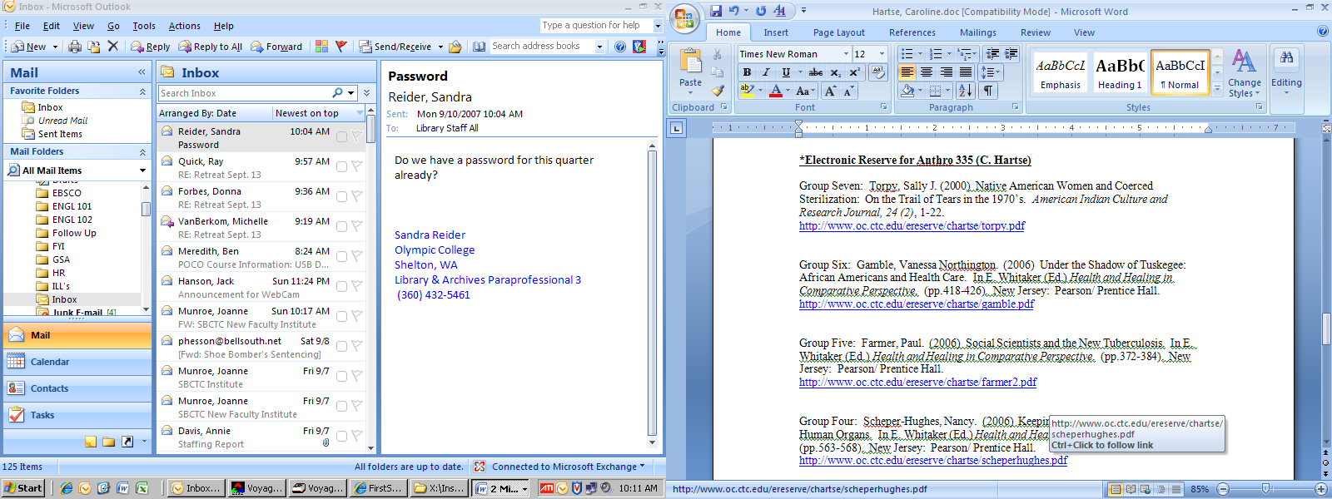

- Open Voyager’s Circulation module. Click the “Reserve” button. This will bring up a list of search options. The easiest is to search by Instructor name. Click on “Instructor” and input their name in the “List Name” field.

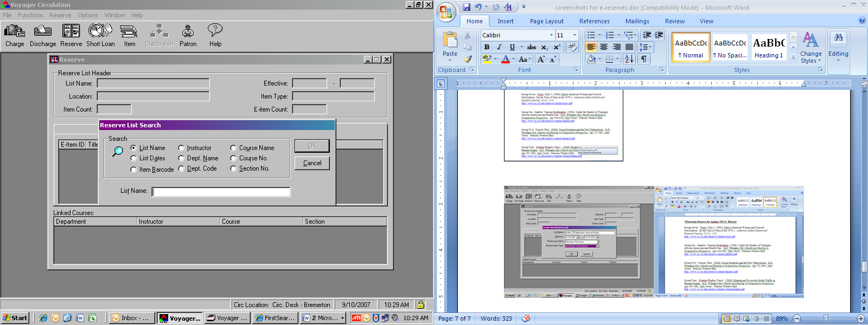

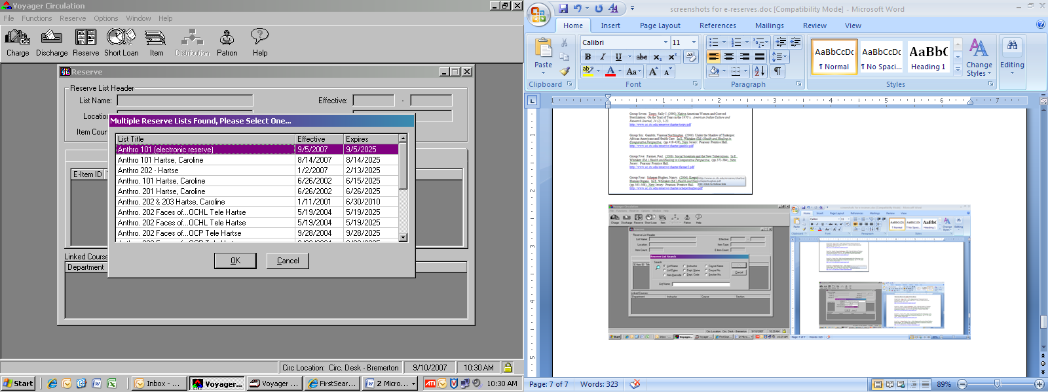
- Voyager will bring up a list of the instructor’s reserve list. Check to see if there is a list that exactly matches three things: Course Number, Instructor Name, and Item Type. As we’re only dealing with electronic reserves, this will be part of the list title, so you won’t have to bring up list after list to corroborate item types. If you find one, click “OK”. If not, you’re going to need to create the list from scratch. Click “Cancel”.

- Go up to the “Reserve” drop-down menu. Click “Create New List”
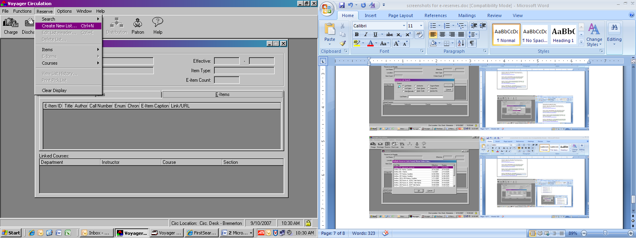

- The List Name, Effective (Date), Reserve Location, and Reserve Item Type fields will all be blank. Fill them in as per the following example.
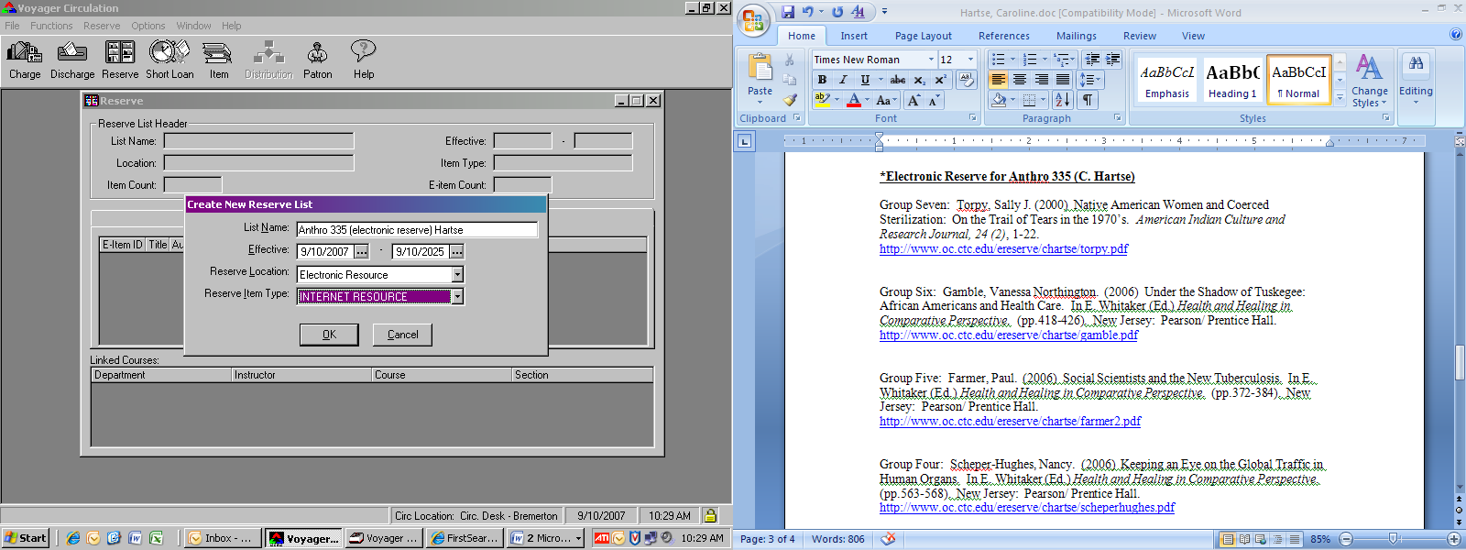
  - Remember that e-reserves always get labeled as such in the list name. If there is room after “(electronic reserve)” for the instructor’s last name, add that, too.
- The first (start) Effective date is going to be the day you are creating this list. The second (end) Effective date depends on what type of faculty the instructor is. Full-Time faculty have an end date of 2025. Adjunct faculty have an end date of 2015. Leave the month and year where they are.
  - Your Reserve Location is always going to be “Electronic Resource” for an e-reserve. Likewise, your Reserve Item Type will always be “INTERNET RESOURCE”. When you’re done entering information, click “OK”

- A window will appear with all of your list information. Notice that it has two different tabs, “Items” and “E-Items”. For some unknown reason, Voyager automatically grays-out the E-Items selection on the Reserve drop down menu. Toggle back and forth between both tabs a few times, making sure that the “E-Items” tab is the one in front when you finish. This should allow the E-Items selection on the drop-down to become active.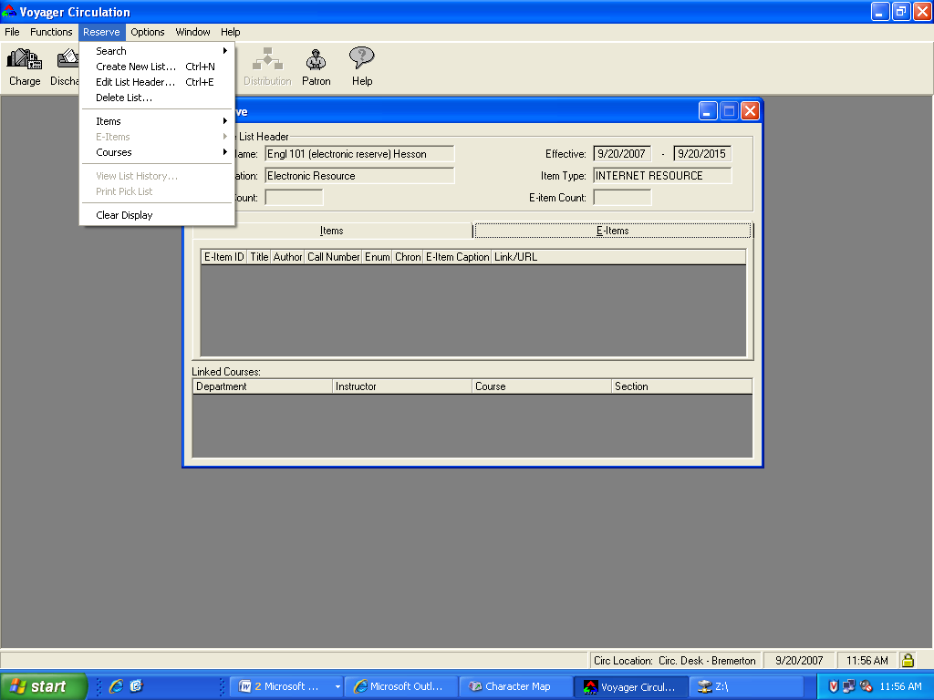

- Click “Reserve” →”E-Items” -> “Add New E-Item, Holding and Bib Record” You only need to do this once with a new list. To add items to an existing list, you should not use this step. Go directly to step 13.
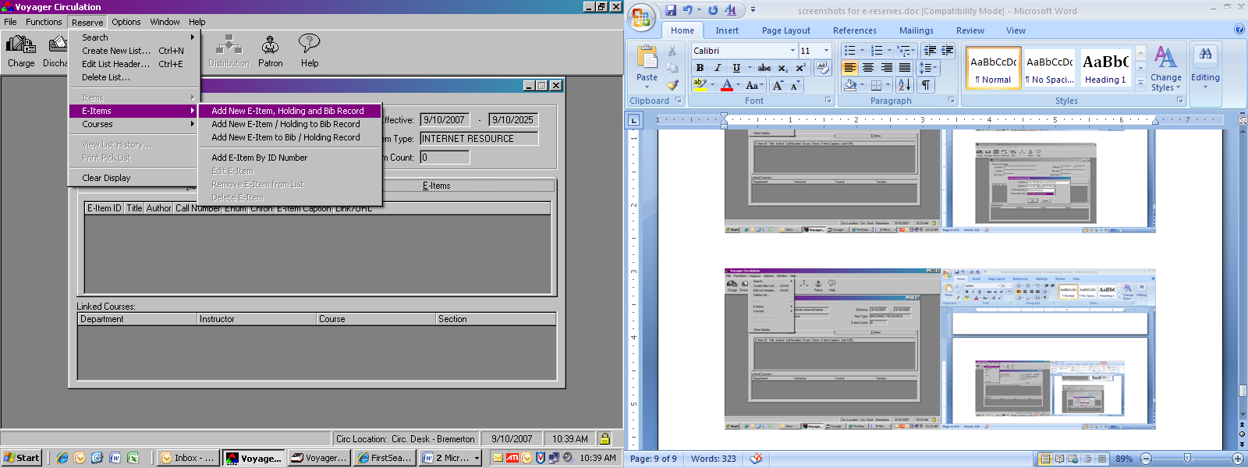

- Voyager immediately brings you to the Bib tab. The only field that you have to enter anything into is the Title field (which is bolded.) Note that the “OK” button stays grayed out until you input all required fields (and there are two more on the “E-Item tab.)
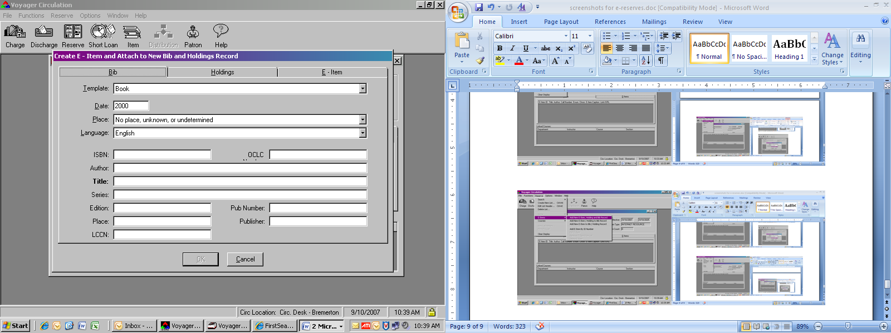
Cut and paste the course title from the citations list:
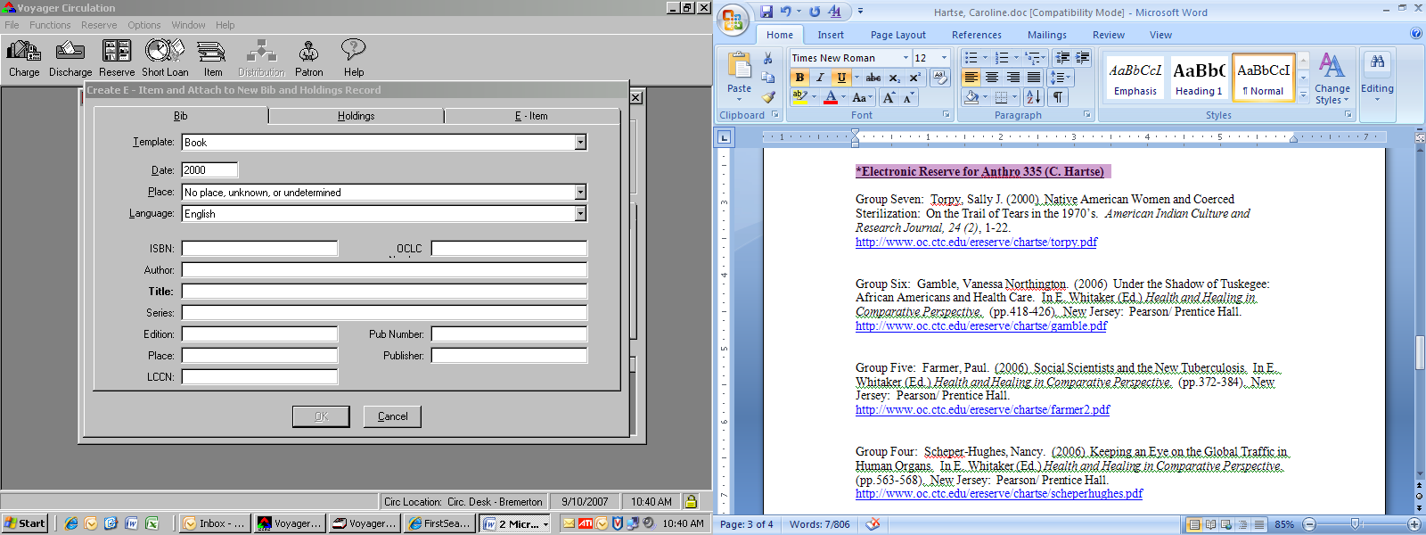

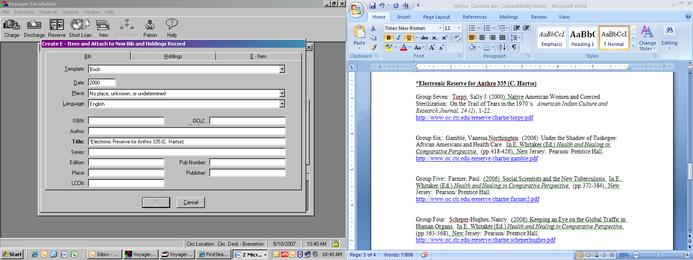

- Click over to the “E-Item” tab. The two fields you will be pasting into are “Link Caption” and “Link / URL”
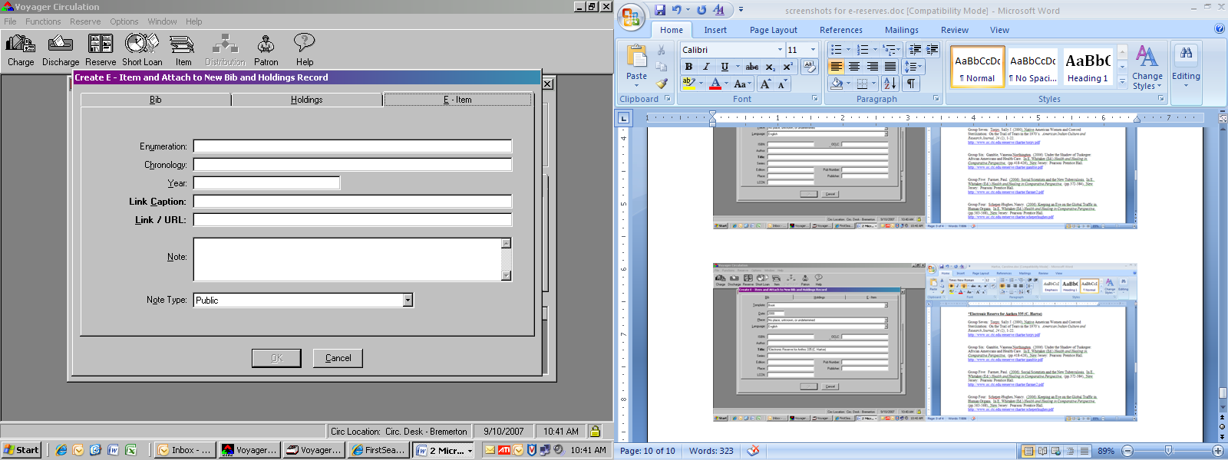

- Link Caption is the citation for the article (plus any accompanying clarification that the faculty member wants the students to have.) Like last time, this is just a simple cut-and-paste into the field.
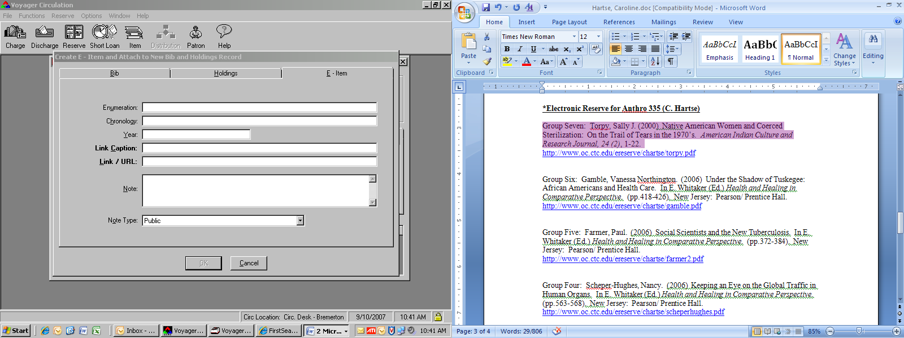

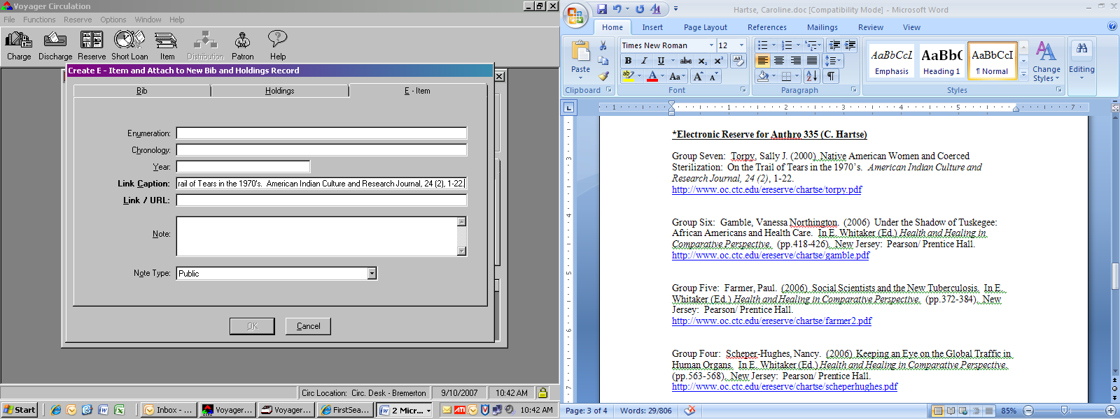

- Do the same for the URL
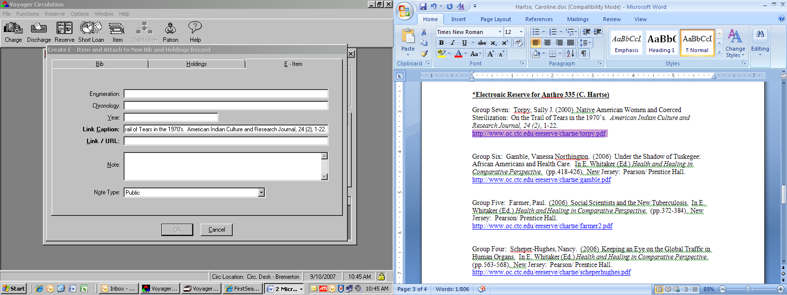
- When you’re done, click the “OK” button.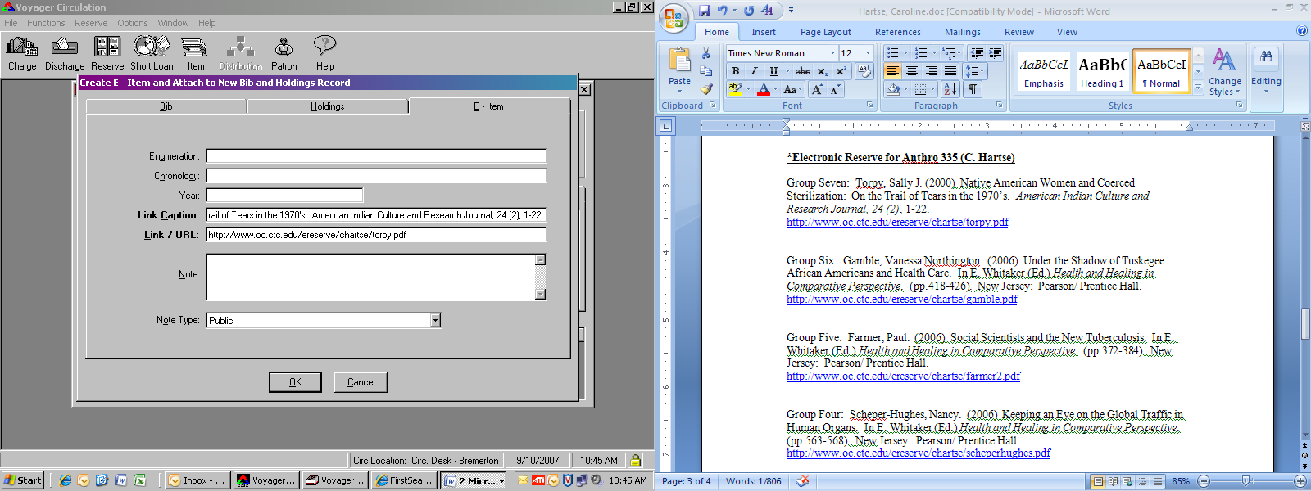
The item then gets displayed on the E-Items tab of the Reserve List Header:
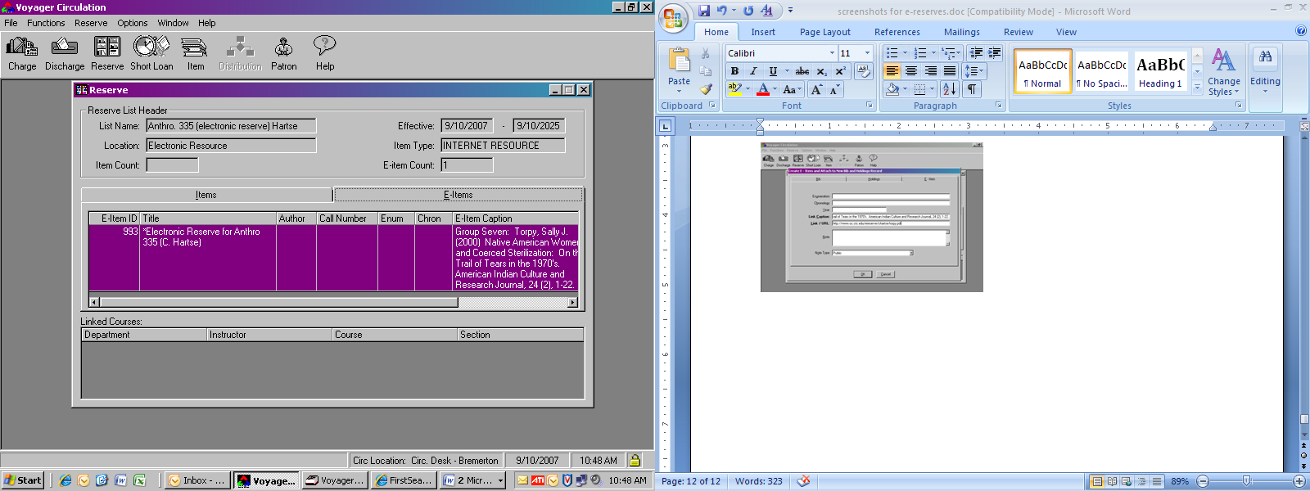

- If you have more items to add to the list, or you’re adding to a pre-existing list, the procedure becomes a little different (and more involved.)
Click “Reserve” →”E-Items” → “Add New E-Item to Holding and Bib Record” (the third item down.)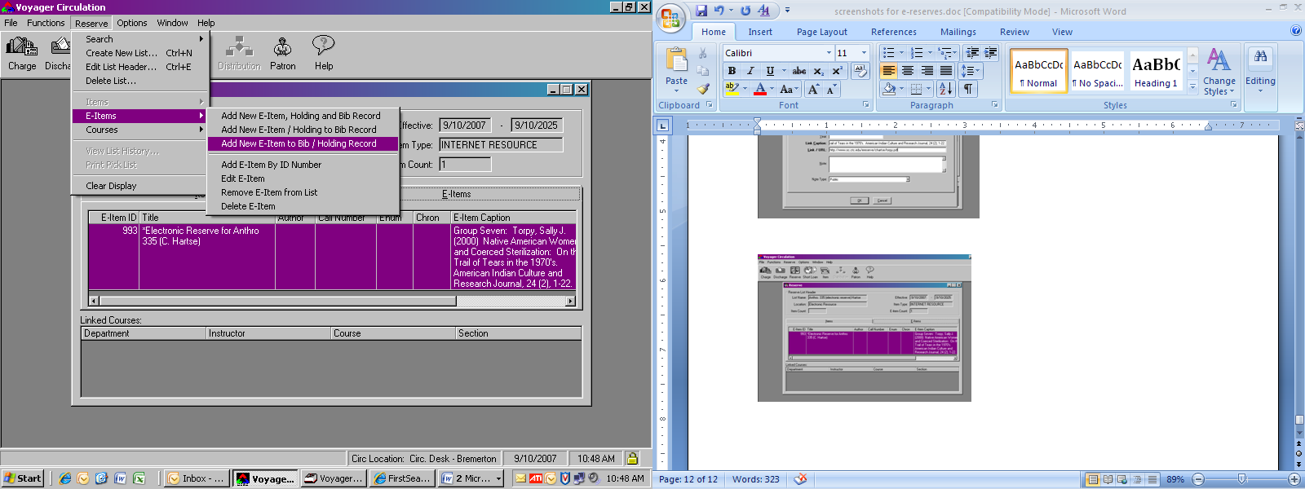

- The search screen pops up. Click on the “Keyword” tab and run a free-text keyword search that includes the instructor’s name, course number, and “electronic reserve”. Click “Do Search”.
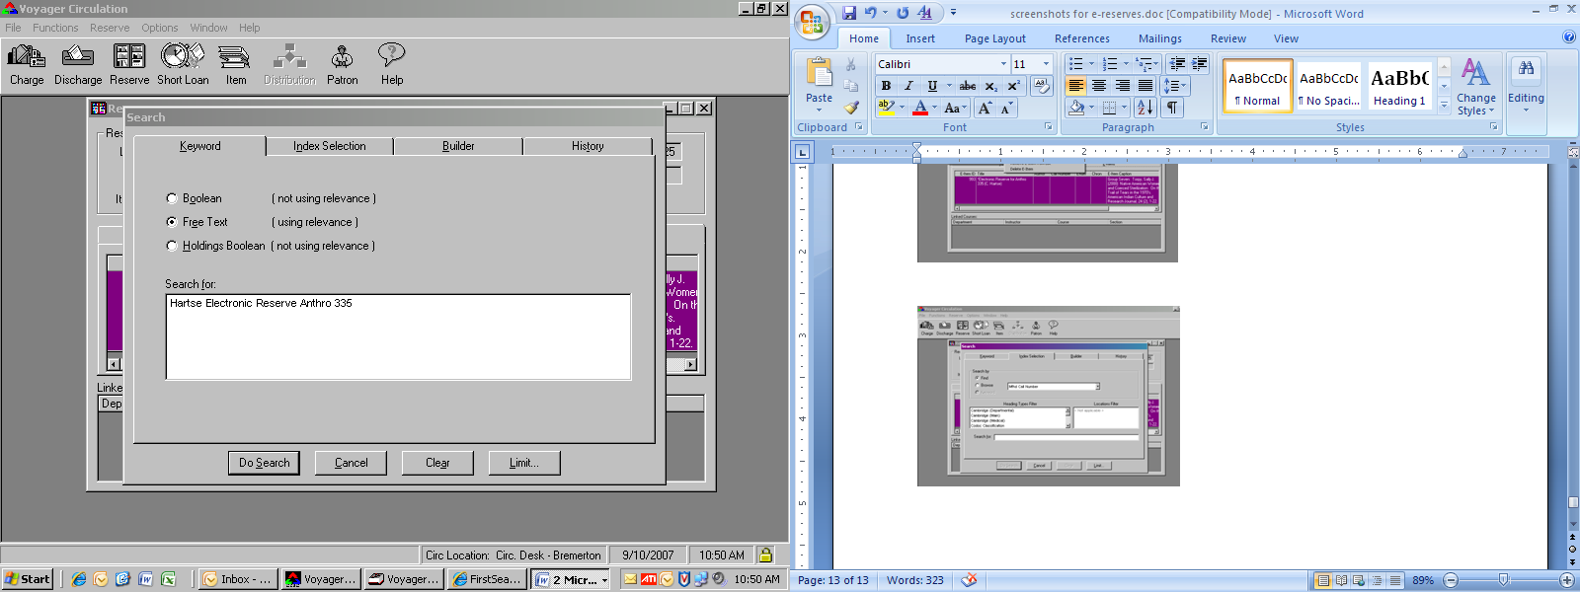
The search usually brings up far more results than you need – once you see the reserve list you’re working with, click “stop”.
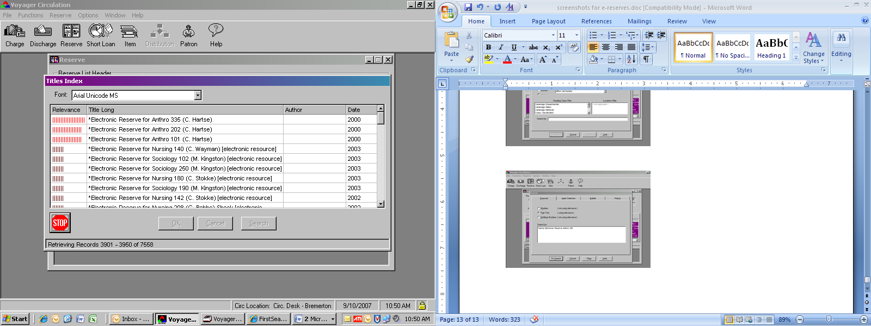

- Highlight the listing you’re using and click the “OK” button.
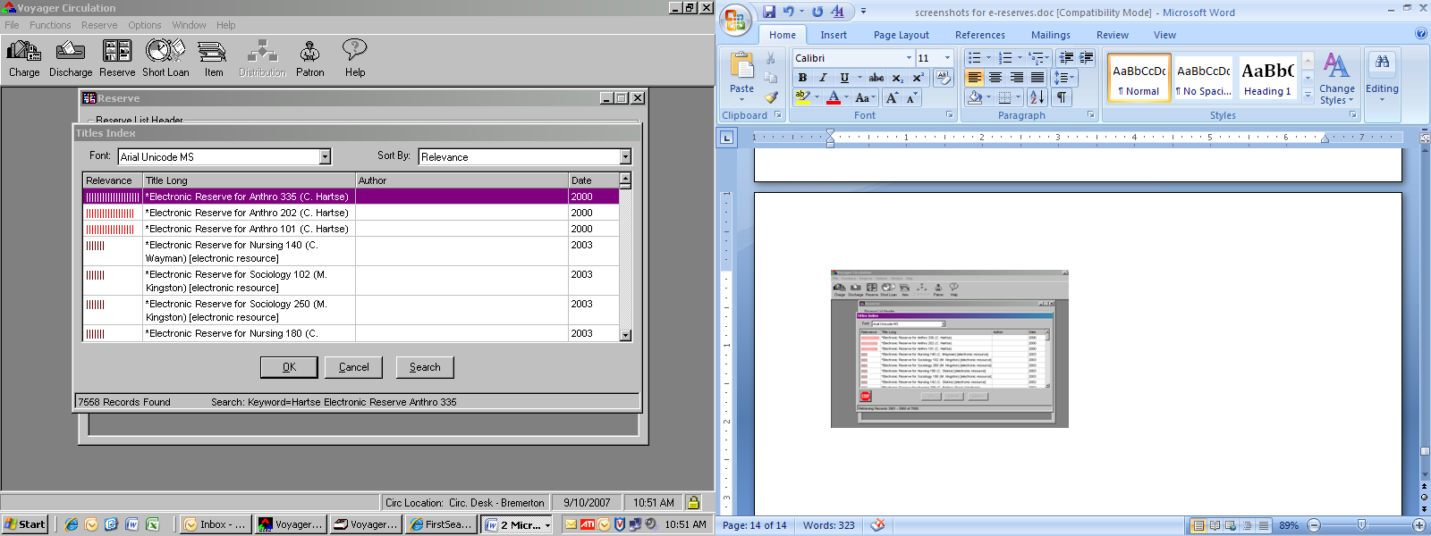

- The same as numbers 9-11, you’re going to click on the E-Item tab and cut-and-paste the Link Caption and URL from the citation list to the fields.
- Click “OK” when you’re done.
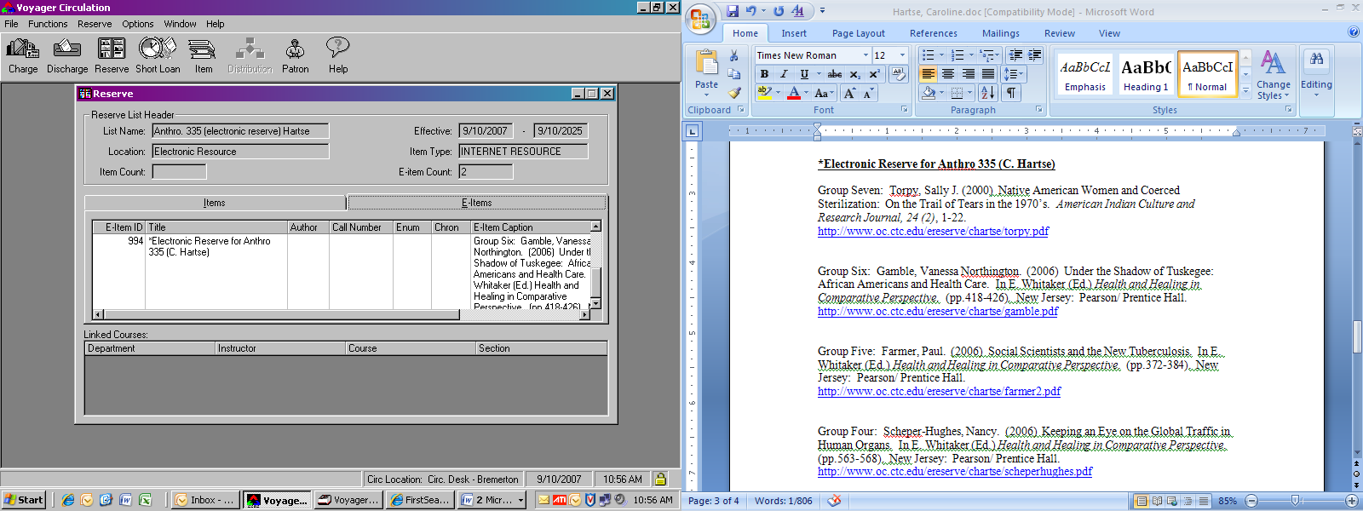

The item doesn’t immediately show up, but if you scroll down under the first entry, you can see the record. Also note that Circ saves your search terms as you add more e-items to the List Header, but can also run the search via. the “History” tab in the search box. Repeat this process until you have all of the e-items attached to the Reserve List Header.

- Now you’re ready to link the course to the List Header. Click “Reserve” → ”Courses” → ”Link Courses”.
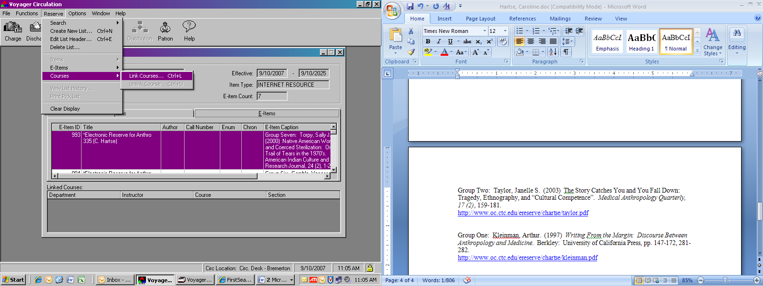

- This brings up the box that allows you to fill in the appropriate information via. drop-down boxes:
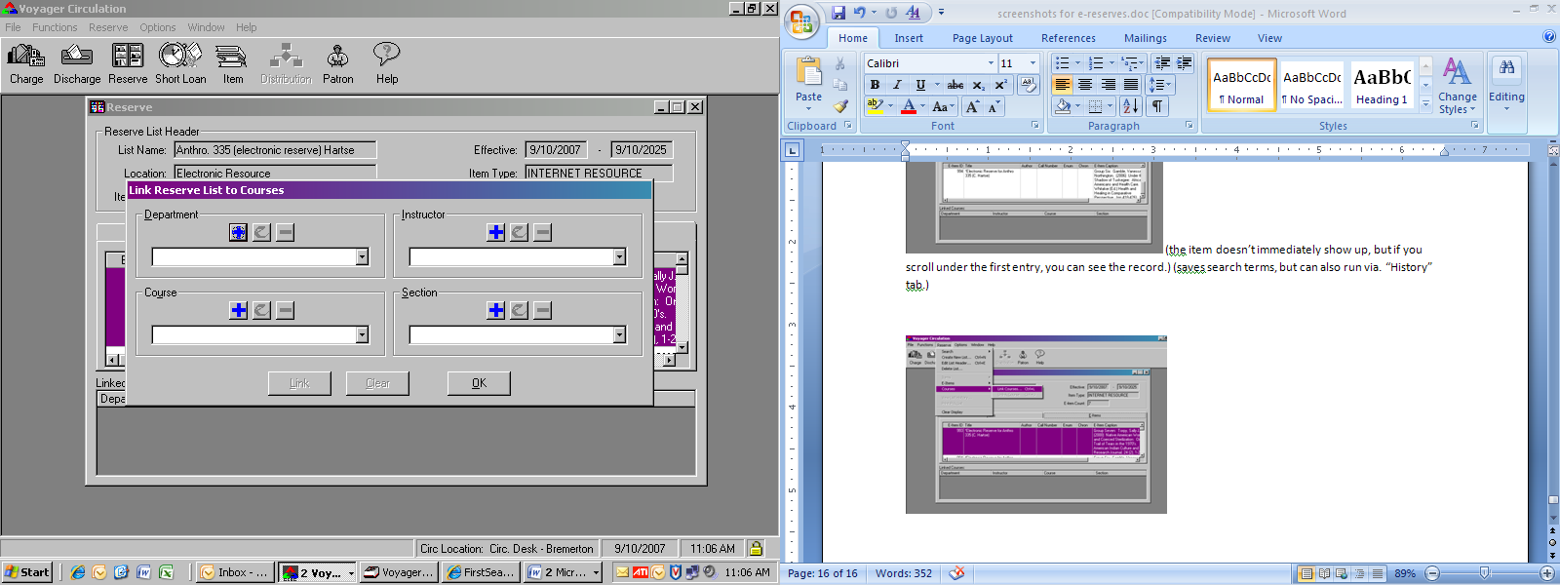

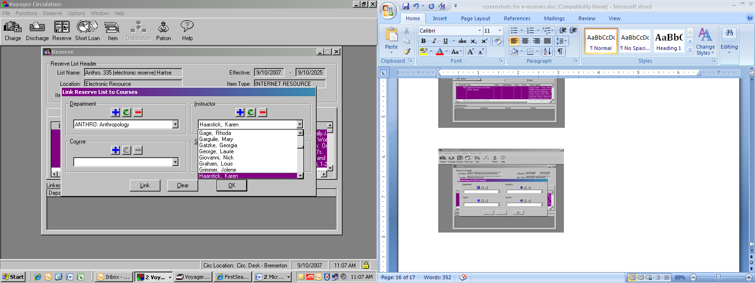

- Occasionally there won’t be a listing for the course (more likely) or the Instructor (less likely.) In this case, you’re going to want to click the blue “add” (plus) sign and fill in the information that the Circulation Module prompts you for:

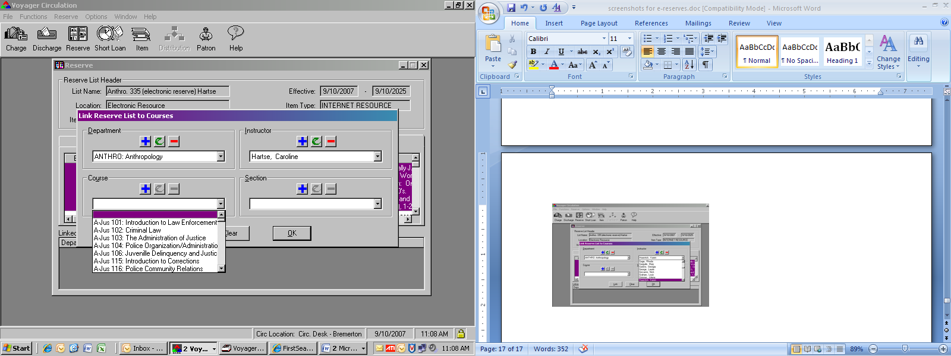

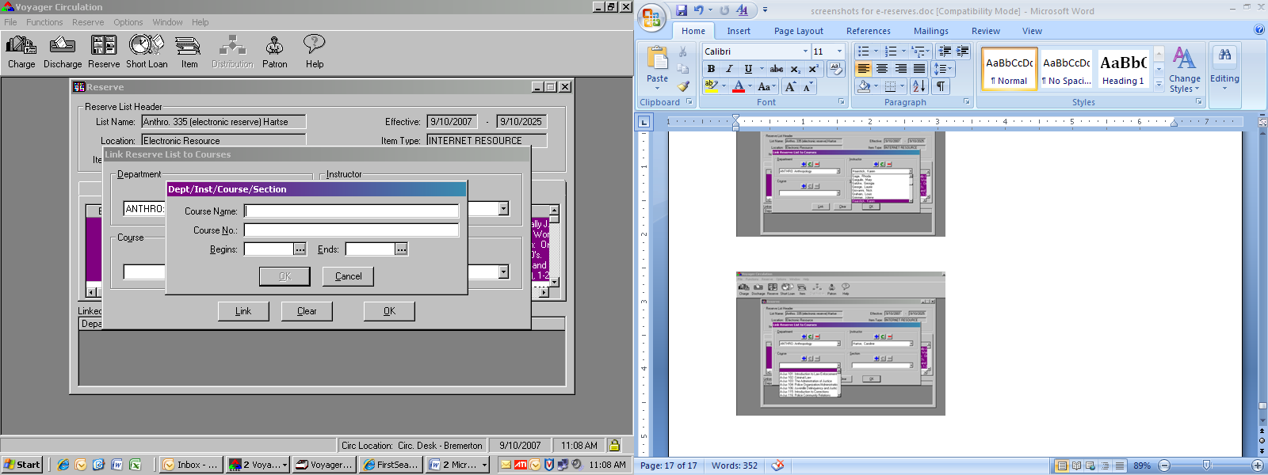

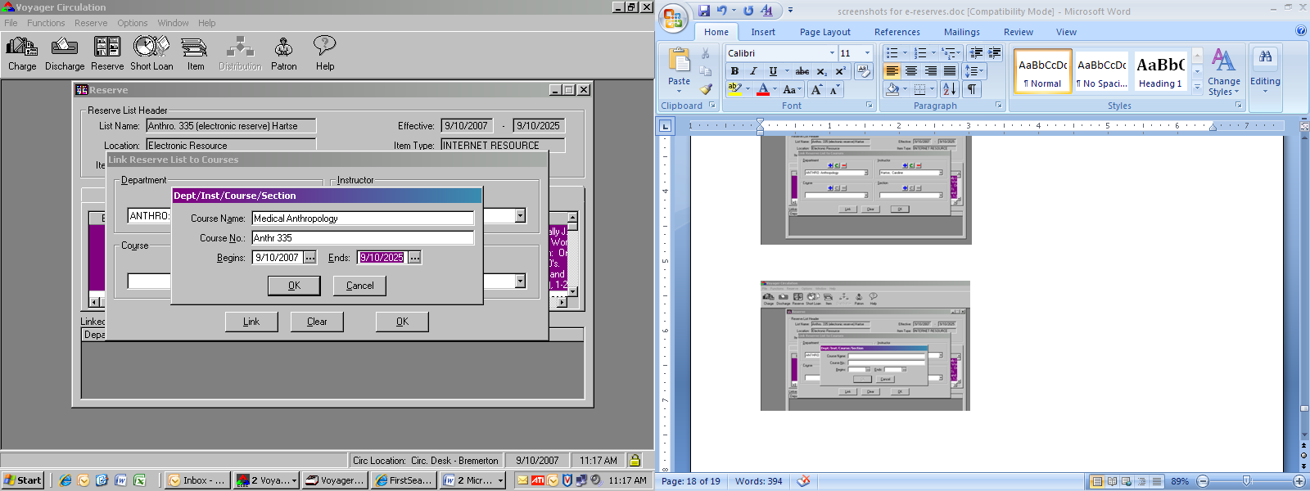(note: since the course re-numbering in Summer Quarter ’08, we’ve moved to typing the course number in all capitals, so this should actually read “ANTH 335” – and does in the system. The course listing treats capital and lowercase letters differently, so “AN” and “An” are not going to be listed together.)

- When you’re through (ignore the “Section” box) click the “Link” button. The course will now be attached to the Reserve Header List, and will also be visible in the OPAC from this point onward. Note that you can link more than one course to a header list. This can be very valuable for departments like Nursing where they have a lot of e-reserves and they tend to switch out who is teaching a particular course quarter-by-quarter.
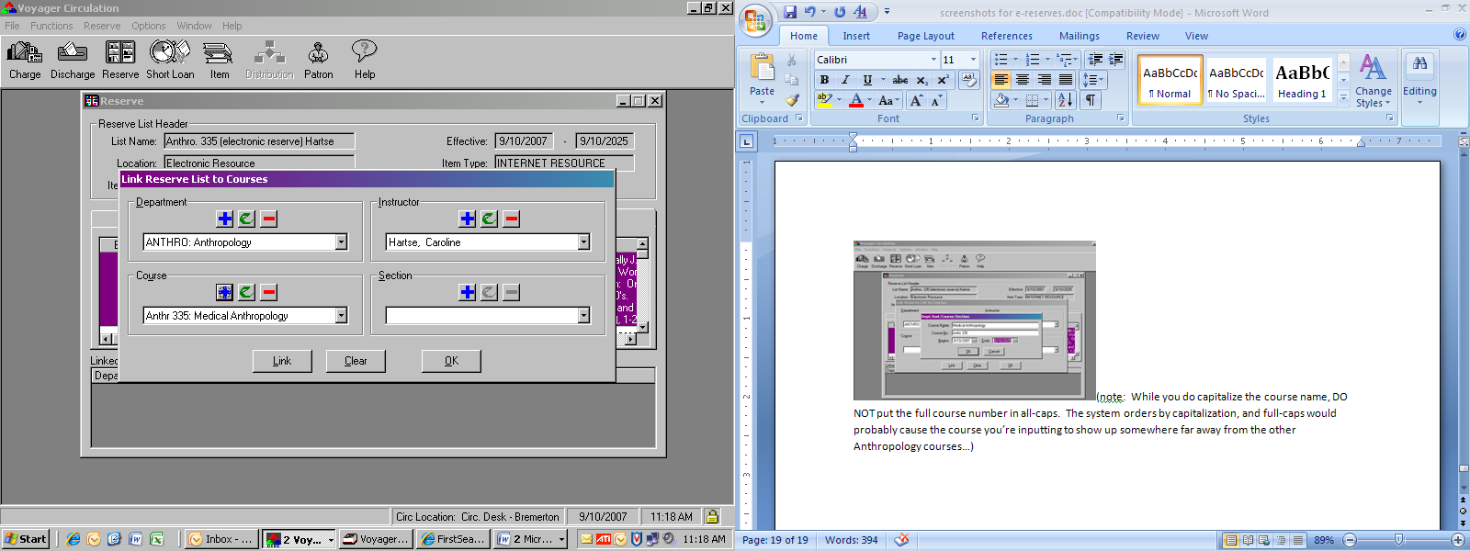

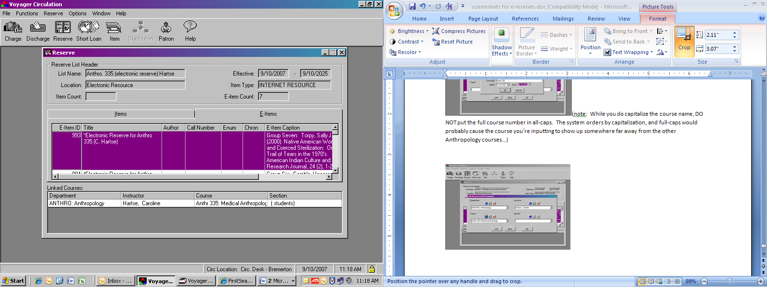

Modifying the MARC Record in Cataloging:

- Bring up the Cataloging Module and do a free-text keyword search for a previous electronic reserve list that you know is still current.
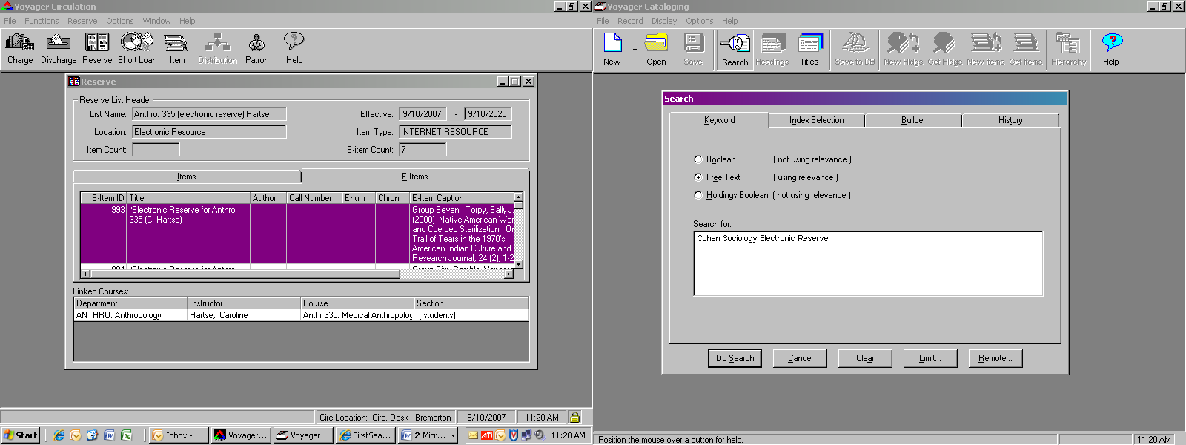

- As usual, press the stop button once you see the one you’re looking for, highlight it and click “OK”.
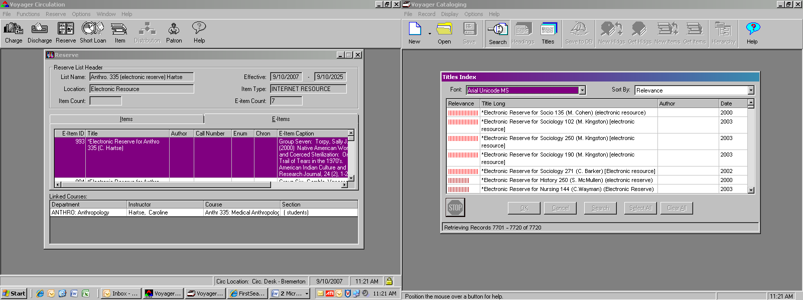

- You’ll notice the two 500 fields that explain formatting and copyright.
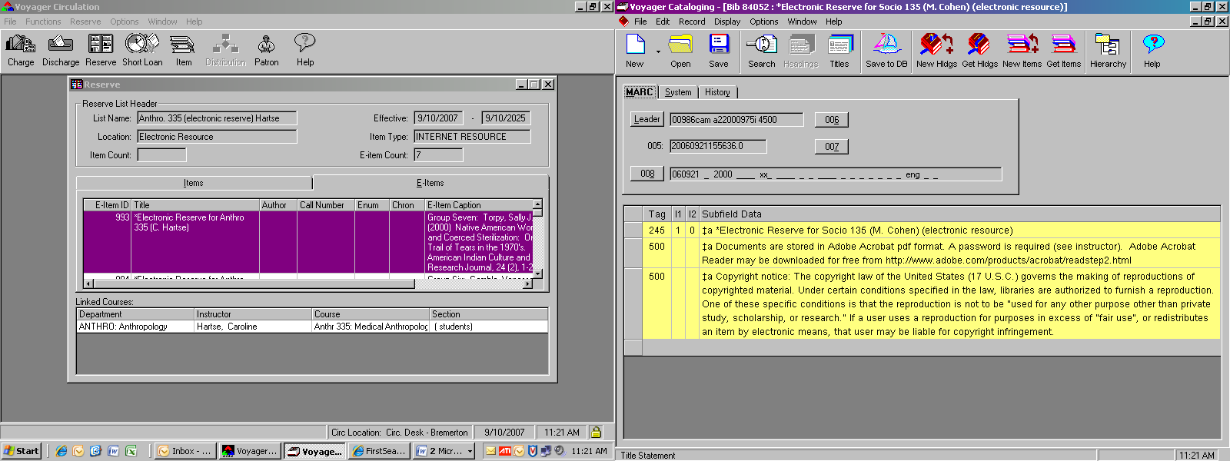
- Highlight both of them and copy them to your clipboard (CTRL+C)
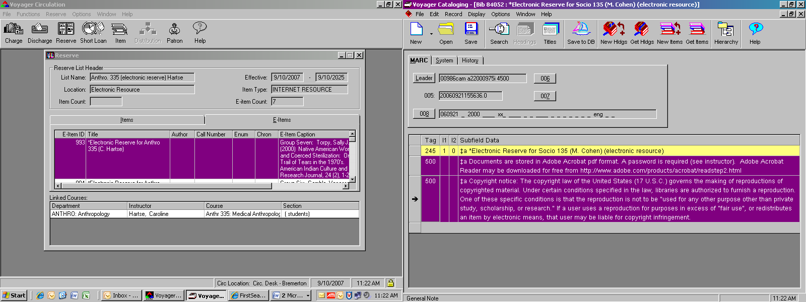

- Do another free-text keyword search to bring up the list you just created. Bring up the record. You’ll notice that it doesn’t have any 500 fields. Highlight the space under the existing field by clicking on it
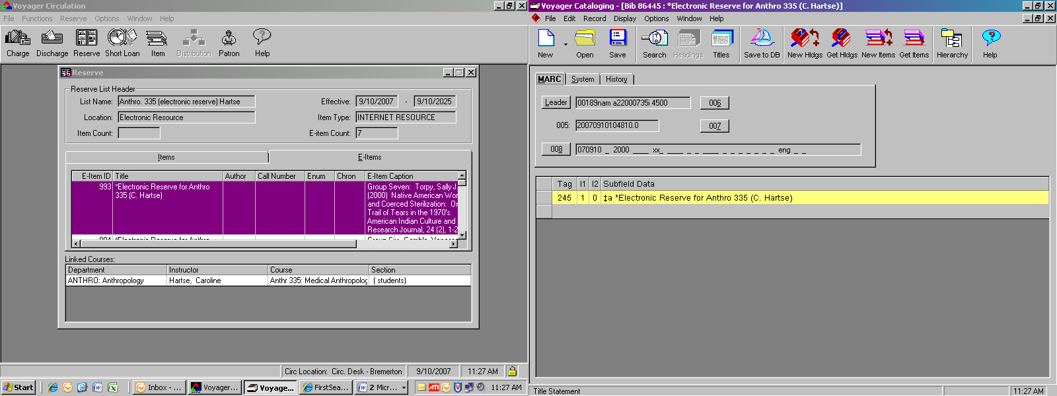

An arrow appears to show that it’s been selected
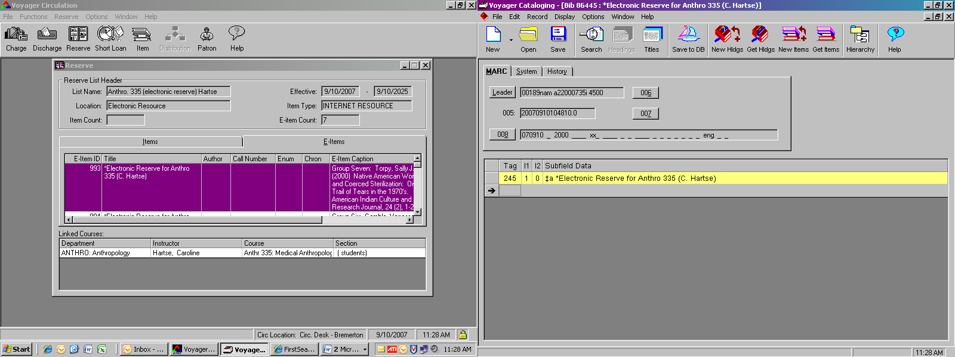

Paste the two fields from your clipboard (CTRL+V) and then save the record to the database (the sailboat icon.)
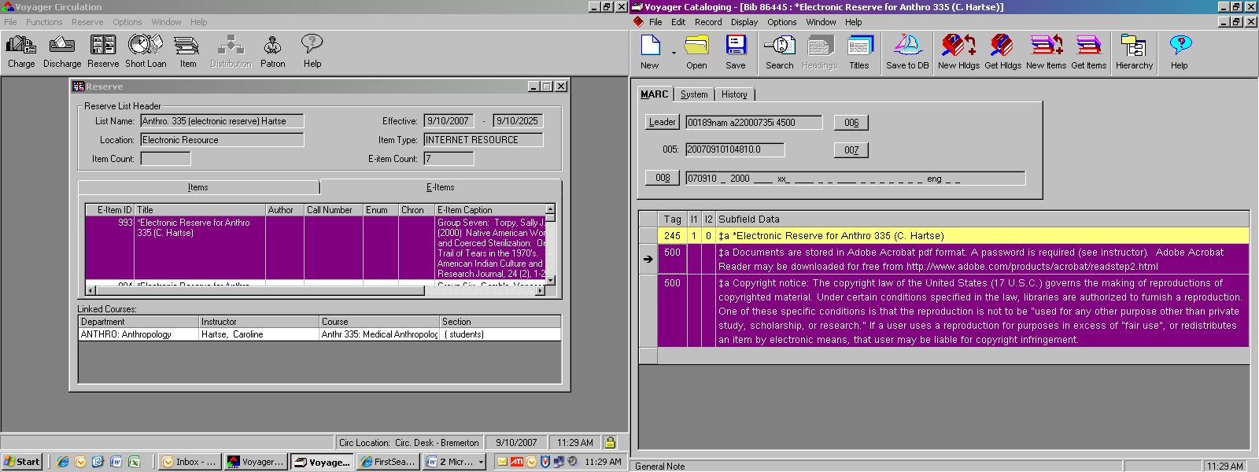

Double-Checking Your Work

- Bring up a Course Reserve search in the OPAC from the library’s homepage. The easiest way to search for the e-reserve is by course number.
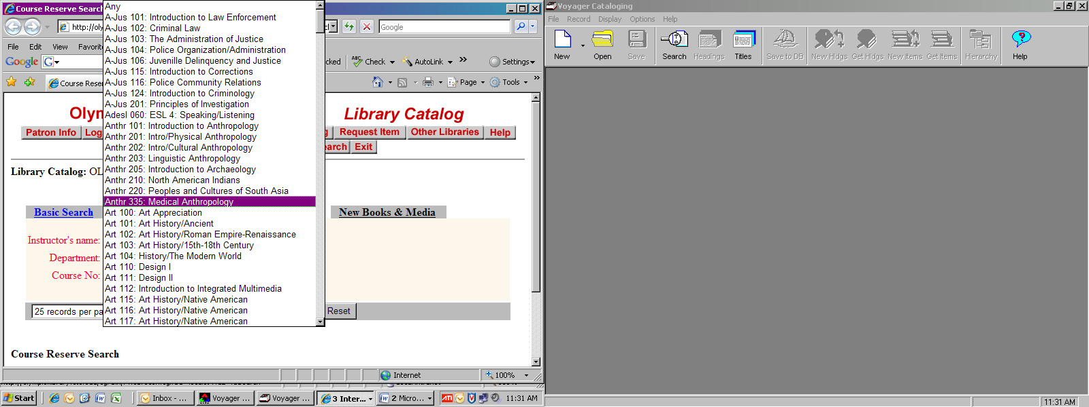

- If you used the asterisk in the title for the e-reserve, it should be the first link on the list. Click it to get to the record (which is where the links to the e-reserve live.)
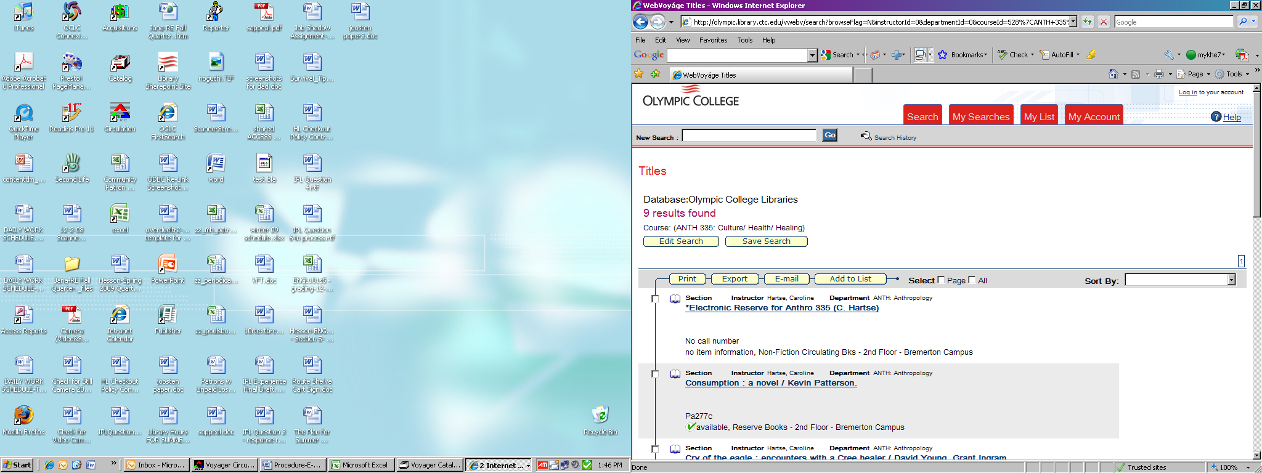

- Click on the links to the articles to test them.
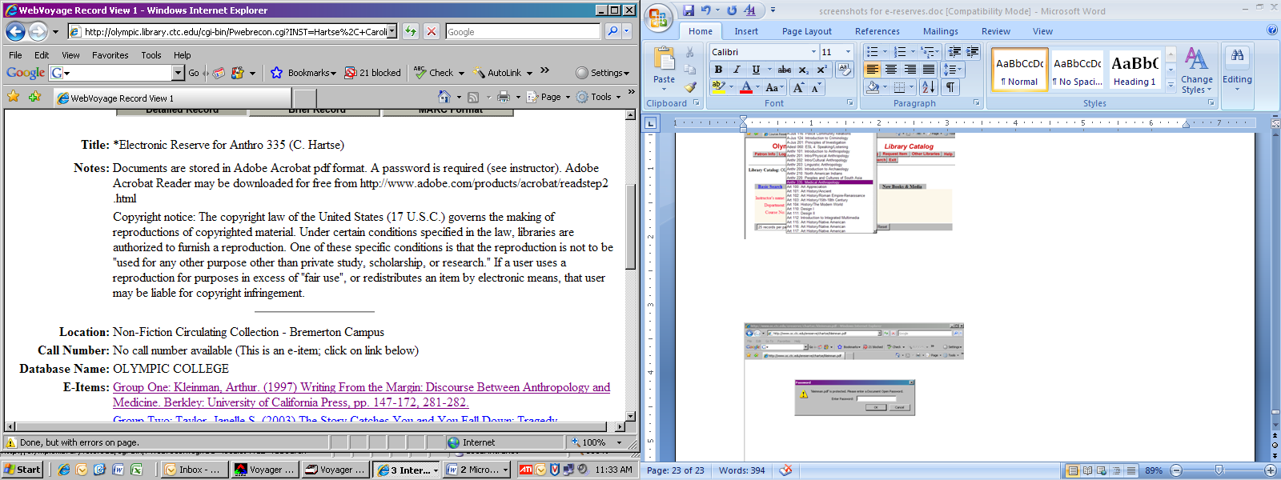

A dialogue box pops up asking for a password. (If one doesn’t pop up and you immediately get the article, you forgot to password-protect the .pdf file, and need to password-protect the article on the X: drive, delete the current file on the server in WS-FTP, and upload the password-protected version. The link should stay the same, so you don’t need to worry about doing anything else in the Circ Module…)
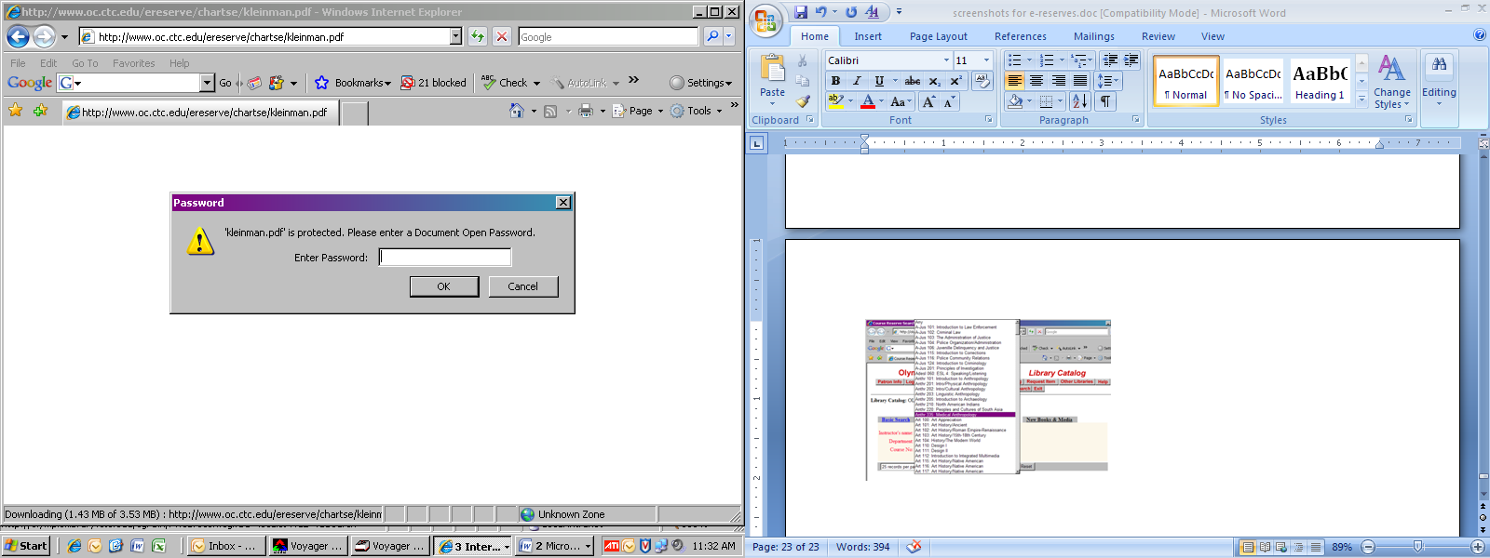

Password is always the instructor’s last name, all in lowercase. Enter it and click “OK”.
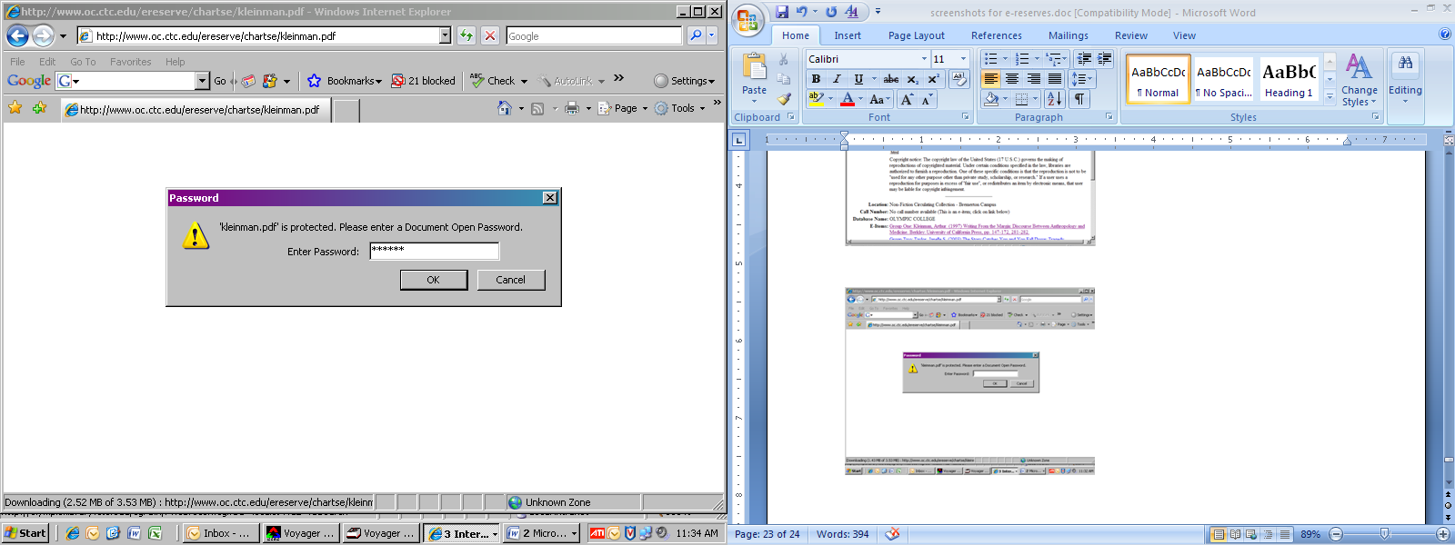

- While you scrolled through the .pdf after scanning it, a quick scroll through the article to make sure everything translated to the server isn’t a bad idea if you have time.
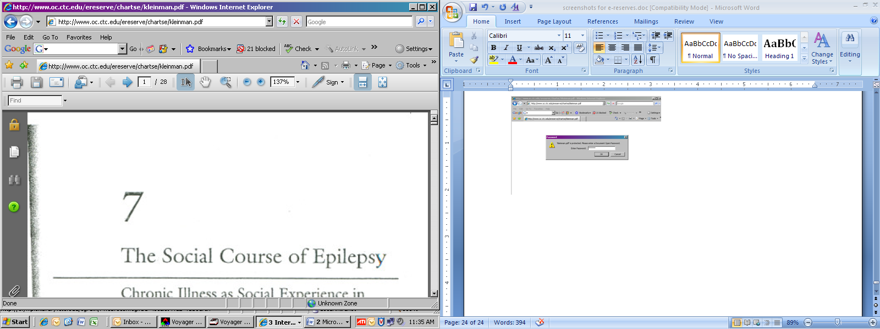

You generally want to check each link/ article that you scanned for the course (this is where an error page shows up if you’ve named either the .pdf or the URL with a capital.) It helps to open the article in a new window (right-click the mouse with your cursor over the link.) That way you don’t have to keep going in and searching for the e-reserves record when you close the article.
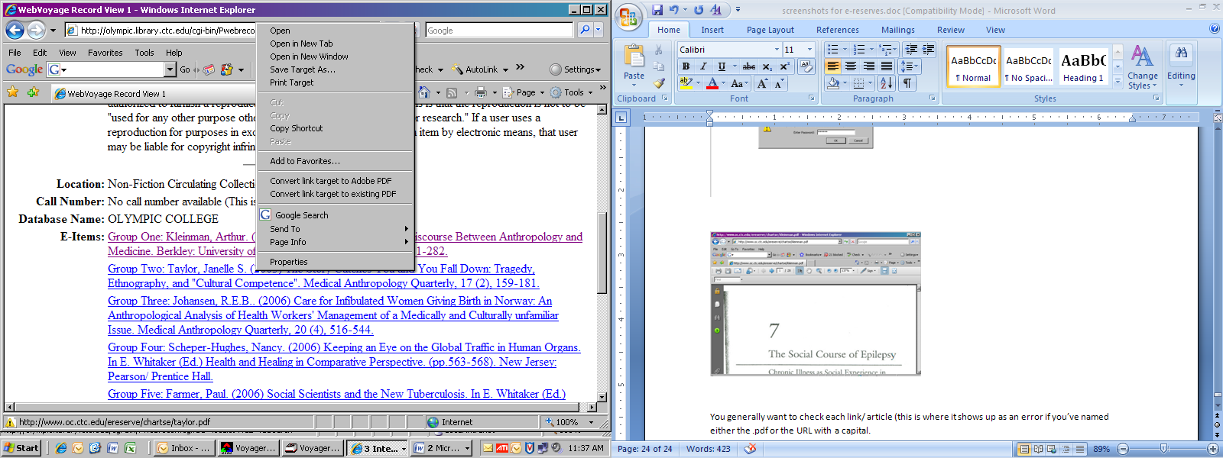

Deleting E-Reserve Items / List Headers

- Go into the Circulation Module, bring up the Reserve List Header that contains the items you want to delete, select the linked course, right click and choose “unlink course”. Voyager will ask you if it should “unlink the selected course”. Click “Yes”.
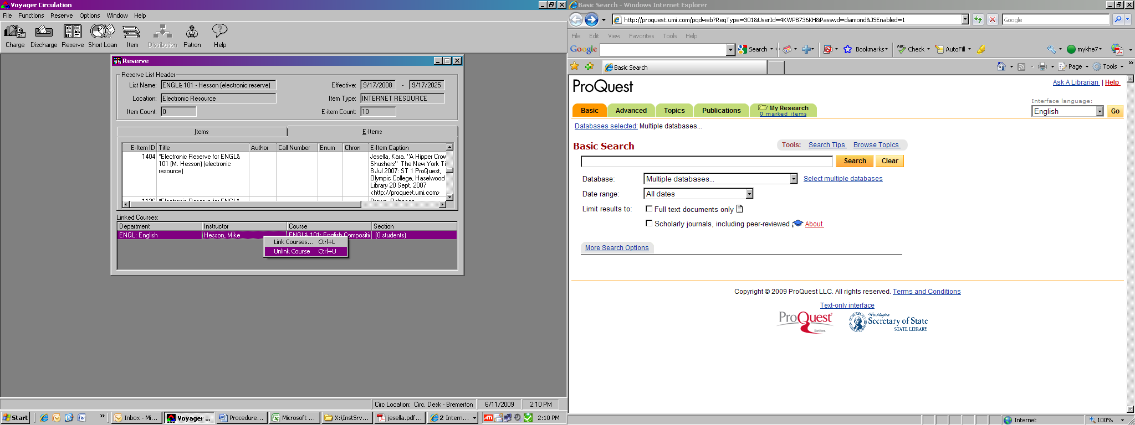

- Highlight the E-Item itself (and make sure you’re on the right one – Voyager doesn’t ask permission this time!), right click and choose “Delete E-Item”. (You do not ever want to chose “Remove E-Item from List” – this creates orphaned E-Items that then have to be manually deleted out of the system.)
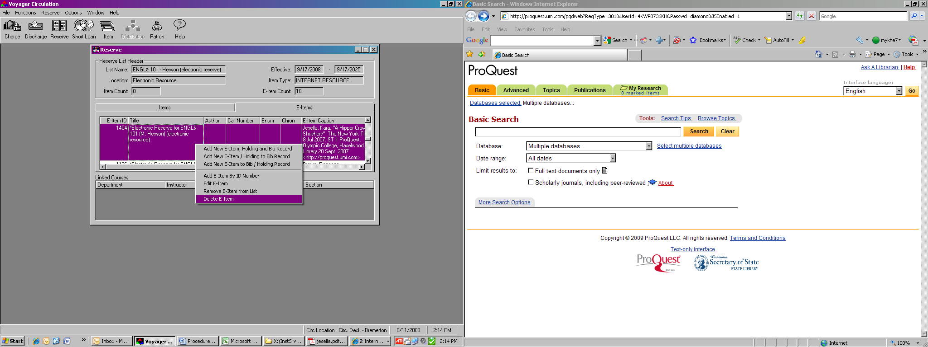

- If you’re deleting an entire list, you want to delete all of the E-Items off of the list. When the E-Item count for the list is 0, then you can click “Reserve” → “Delete List”. (Voyager will ask you if you really want to delete the list. Click “Yes”.)
